First Mennonite Church of Christian
Pastor Laura Goerzen, Organist – Hazel Voth
April 4, 2021

Gathering and Praising

Welcome

Announcements

Call to Worship – Pat and Dwight Goering

One: And while it was still dark, Mary found the light!
Many: The disciples came running, but they did not understand.
One: Mary stood weeping and saw angels but did not recognize Jesus.
Many: But when Jesus calls our name, then we recognize the way, the truth, and the life.
One: And then there was feasting! And there is feasting to come. God will make for all peoples a feast of rich food and well-aged wines and will wipe away tears from all faces.
Many: It will be said on that day, “This is our God for whom we have waited; let us be glad and rejoice. There is peace by Jesus Christ.”
One: Hold firmly to the good news, which you received, in which you stand, through which you are being saved.
ALL: Let’s open the gates of righteousness to enter through them and give thanks to the Lord.

Song - “Thine is the Glory” HWB #269

Old Testament Reading – Isaiah 25:6-9

Children’s Time

Special Music – from FMCC Choir archives

New Testament Reading – John 20:1-18

Receiving God’s Word

Sermon

Affirmation of Faith

Many: Deep calls to deep. We give thanks from the depths of our hearts!
One: Once weeping, now proclaiming: “I have seen the Lord!”
Many: Once famished, now feasting: “This is the God for whom we have waited!”
One: Once divided, now convicted: “Jesus Christ is Lord of all!”
Many: We shall not die but we shall live and keep telling the deeds of the Lord.
One: Deep calls to deep. You call to us from the depth of your love, O God. You have come to us in Jesus Christ.
Many: We answer your call to deep living!

Song – Here, O Lord, I See Thee HWB #465, v. 1-3

Sharing the Lord’s Supper

Sharing with One Another

Sharing Joys and Prayer Requests

Prayer of the Church

Going in God’s Name

Sending Song – Low, in the grave he lay #273

Benediction

Pastor Laura Goerzen
Pastor Laura’s email: laura.n.goerzen@gmail.com
Pastor Laura’s Cell Phone: 620-386-0518
Pastor’s office Hours: Mon. 10:00AM-Noon, Wed/Thurs. 10:00AM-3:00PM

Study Phone 620-345-8766
Church Secretary: Lurline Wiens
Lurline’s phone number: 620-345-6657
Lurline’s email: fmcc.secretary1@gmail.com
Office hours: Tues. 1:00-4:30PM, Thurs-Fri. 8:30AM-11:30am
Church Phone: 620-345-2546
Church Website: www.fmccmoundridge.org

Deep in the Feast

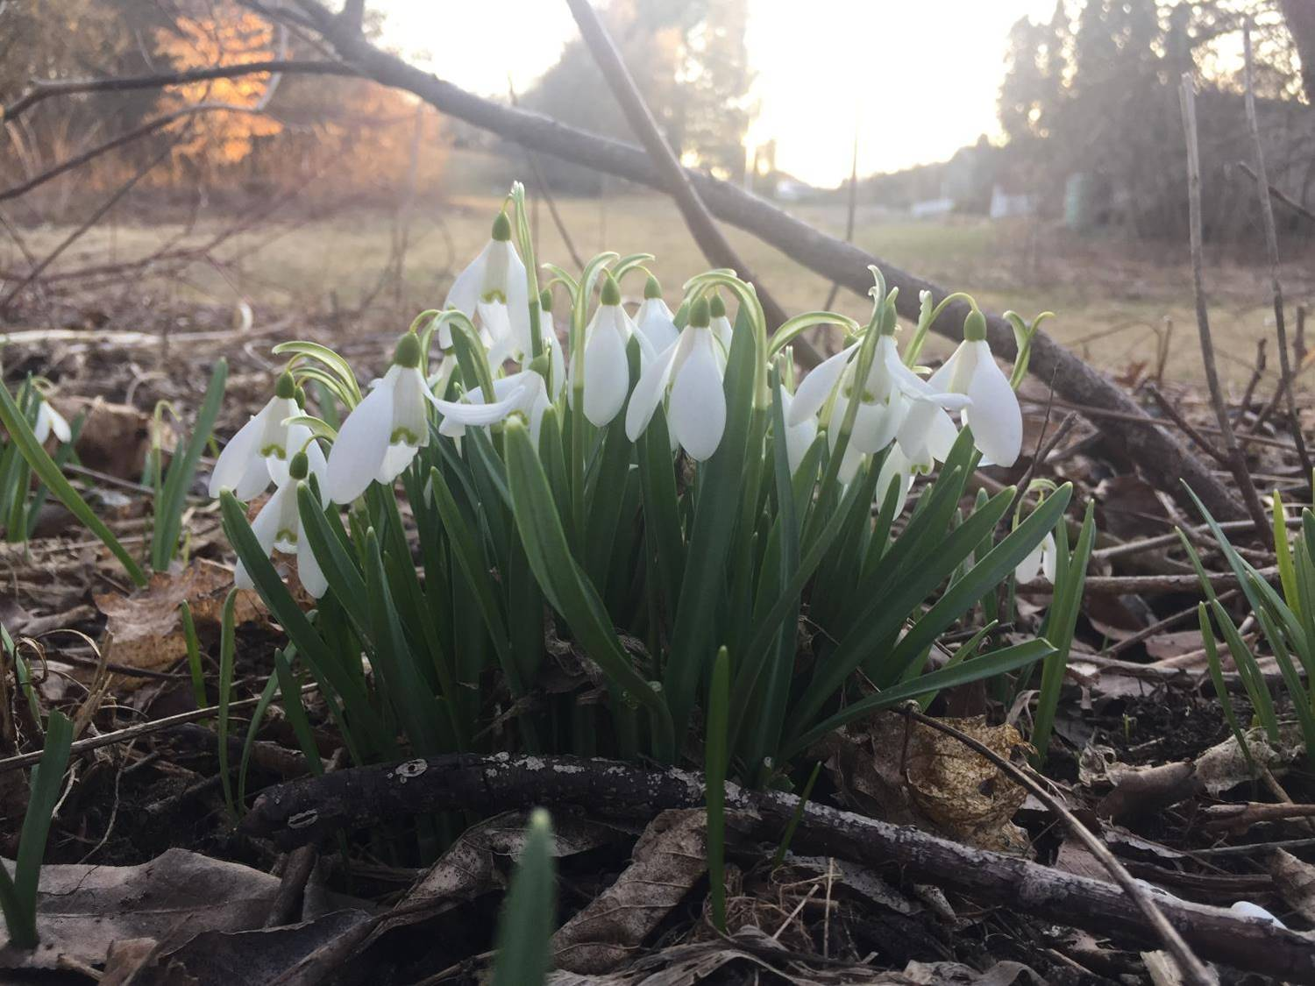

First Mennonite Church of Christian
Moundridge, KS
A welcoming Community of Christians for Peace
Easter Sunday
April 4, 2021

Opportunities
Today: 7:00 am Easter Sunrise Service
9:30 am Sunday School
10:00 am First Perk
10:30 Worship Service
Communion

April 7: Worship Team. 10:00 am
April 11: Education Sunday at West Zion, 10:30AM
April 21: Deacons – 7:00 pm
Church Board – 8:00 pm

Sunday, April 18: Organist – Lu Goering, Special music – Bruce & Mary Kay Stucky

Righteousness and justice are the foundation of your throne;
love and faithfulness go before you.
- Psalm 89: 14

Announcements

First Perk at 10:00AM. You are invited to in-person First Perk, beginning this Sunday at 10:00AM. Come join us around the large, round tables in the Fellowship Hall (with your mask!) for fellowship and conversation. Each family unit should sit at a separate table.

Directions to NEW Easter Sunrise Location: Go North on Christian out of Moundridge. Turn East on Cherokee Road. Turn South on the access road to the Black Kettle State Fishing Lake (or "North Pond"). Turn Left at the fork around the lake. Follow the road down and up through the drainage point and turn left onto the grass at the top of the hill. Parked cars and the worship spot will be easily visible once you pass the drainage point. Park on the grass by the fence and go through the fence onto Russ Stucky's property.

Education Sunday at West Zion. West Zion will stream their April 11 service on Facebook live and provide an online recording following the event.

Camp Mennoscah announcements are posted on the south bulletin board. Be sure to check them out.

Mobility Worldwide/PET is going on a distribution trip to Guatemala, April 24-May 3. Anyone interested in helping with expenses for projects and distribution please make your check to Mobility Worldwide with Trip on the memo line and give to Kirby or Chris Goering. Thanks.

As a service of the Moundridge United Methodist Church, we have started a short term, small medical equipment rental program for the Moundridge and surrounding areas. The program is designed to be of no cost to the renter. We however would like to have the equipment returned in good condition as soon as the individual is done with it. we will clean and disinfect it for the next person. Questions concerning this program should be directed to 785-826-0809 or 785-787-0621 and not the church.

MCC Sale plants and things…Mark your calendars for the Annual KMRS Plants and Thing Sale. Because of the move of the MCC Sale to July, we are selling plants, seedlings, flowers, vegetables and many more items on Saturday, April 10, starting at 9:00 AM and running through the day, closing at 6:00 PM. The Sale will be held at the MCC Building in North Newton, Kansas and will utilize the MCC Buildings as well as the parking lot to allow for proper social distancing and having plenty of room to spread out the flats brought in from greenhouses for the Sale and the many donations by our local gardeners. This is your opportunity to prepare for your gardening year, and to support the great work of the Mennonite Central Committee. Credit Cards will be accepted.
If you have donations of plants to make, please bring them to the MCC Building on Friday afternoon, April 9. This will be a drive through donation with volunteers greeting you and collecting your donations of tomato plants, cabbage sets, etc. If you wish to make a donation and can’t make this time frame, please contact Kristi at 1-620 367-2721 or email kdunruh97@gmail.com

MCC Sale Quilter's Corner welcomes your donated QUILT-RELATED ITEMS throughout the year. These used/unused/unfinished items no longer needed in your quilt/sewing/linen closets will be sold to generate funds for MCC relief work around the world. The Fall 2020 Quilter's Corner brought in over $23,000 for MCC.
SUGGESTED ITEMS:
• finished/unfinished quilt tops
• finished/unfinished quilt blocks
• old and damaged quilts
• quilt supplies and tools
• linens
• cloth sacks
• quilt books
• quilt magazines (2011 – current)
• quilt patterns
• notions
• fabric – cotton
Items may be dropped off at the MCC Center in North Newton throughout the year. Boxes and bags should be labeled Quilter's Corner. These items can also be collected at churches and sent to sale meetings with sale liaisons. Questions?? Ann Yoder Smith 919-604-3282 rws.ays@gmail.com

