**Opportunities**

**Today**: 10:30AM Worship Service

August 15: FMCC Prayer Time, 9:30AM

August 19: Book Talk, 6:00PM, in First Perk

August 22: FMCC Prayer Time, 9:30AM

August 22: Deacons Meeting, 3:45PM

August 29: FMCC Prayer Time, 9:30AM

August 29: Board Meeting, 8:00PM

Sept. 13: Worship Team meeting, 9:30AM

Sept. 16: Church Picnic, 5:30PM

Sept. 23: Worship at Pine Village, 10:30AM

August 18th: Organist –, Greeters –Worship Leader –

**We seek and practice shalom**

What difference does it make if you make your promise inside or outside a house of worship?  A promise

is a promise.  God is present, watching and holding you to account regardless.

                                                       - Matthew 23, *The Message*

**Prayers for Peacemakers**

a

Pathways to Peace

August 12, 2018

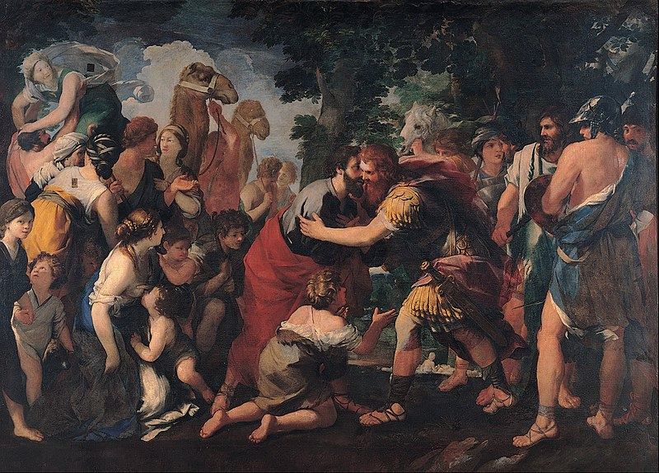

First Mennonite Church of Christian

Moundridge, KS

A Welcoming Community of Christians for Peace

**Receiving God’s Word**

Children’s Invitation Laura Goerzen

Sermon Laura Goerzen

Jesus help us live in peace STJ#52

**Sharing with One Another**

Sharing Joys and Concerns

Prayer of the Church

Offertory

Offertory Prayer

**Going in God’s Name**

*\* All praise to our redeeming Lord #21, v. 1,2,& 5*

*\*Spoken Benediction*

Postlude

*\*Those who are able are invited to stand*

**Welcome to First Mennonite Church of Christian**

Pastor—Laura Goerzen, Organist –, Greeters-, Worship Leader –

August 12, 2018

**Gathering and Praising**

Prelude

Welcome

Opening Prayer

*Lord, I am fondly, earnestly #514

*\*Passing the Peace*

Scripture Reading Genesis 25:29-34

*Special Music Praise God from whom #118

Second Scripture Reading Genesis 33:1-11

Pastor: Laura Goerzen

Pastor Laura’s email: laura.n.goerzen@gmail.com

Pastor Laura’s Cell Phone: 620-386-0518

Pastor’s Office Hours: Tues.—Fri. 9:30AM-1:30PM

Study Phone: 620-345-8766

Church Secretary: Shenise Allen

Shenise’s Cell Phone: 620-334-0190

Shenise’s email: fmcc.secretary1@gmail.com

Office hours: Tuesday 3:30-4:30, Thursday 7:30-9:00

Church Phone: 620-345-2546

Church Website: [www.fmccmoundridge.org](http://www.fmccmoundridge.org)