First Mennonite Church of Christian
Pastor Laura Goerzen, Organist – Hazel Voth, Greeters – Dale & Connie Germeroth, Worship Leader – Gin Niehage
November 10, 2019

Gathering and Praising
Prelude

Introit FMCC Singers

Welcome

Announcements

Call to Worship - “Risk a Mystery”
Leader: It is a risk to come to worship today.
People: This is a place where believers worship what cannot be seen,
Leader: choose to participate in a living mystery,
People: and try-with all of the Spirit’s help-to allow transformation within their lives, the church, and the world.
Leader: This is a place where believers try-with all of the Spirit’s grace-
People: to risk letting go of familiar but stubborn ways in order to believe, receive, and love anew.

Opening Prayer

*Gathering Hymn – “Joyful, joyful, we adore thee” #71 v. 1-3

*Passing the Peace

First Scripture Reading – Matthew 5:43-48

Special Music FMCC Singers
Second Scripture Reading – Acts 10
Hymn of Praise – “You’ve got a place” STJ #4

Receiving God’s Word

Sermon–“A Veteran’s Day Sermon for Mennonites” Laura Goerzen

Hymn of Response – “We are people of God’s peace” #407

Sharing with One Another

Sharing Joys and Concerns

Prayer of the Church

Harvest Thanks Offering

Offertory Prayer

Going in God’s Name

*Sung Benediction FMCC Singers

*Benediction

Postlude

*Those who are able are invited to stand

Pastor Laura Goerzen
Pastor Laura’s email: laura.n.goerzen@gmail.com
Pastor Laura’s Cell Phone: 620-386-0518
Pastor’s office Hours: Tues.—Thurs. 9:30AM-1:30PM,
Fri. 1:00-4:30PM

Study Phone 620-345-8766
Church Secretary: Lurline Wiens
Lurline’s phone number: 620-345-6657
Lurline’s email: fmcc.secretary1@gmail.com
Office hours: Tues. 1:00-4:00PM, Thurs-Fri. 8:30AM-12:00pm
Church Phone: 620-345-2546
Church Website: www.fmccmoundridge.org

Veteran’s Day for Mennonites

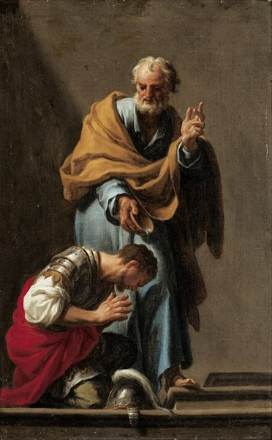
First Mennonite Church of Christian
Moundridge, KS
A welcoming Community of Christians for Peace
November 10, 2019

Announcements

Where is the Prayer Quilt? The Prayer Quilt is back at the church.
Friendship Circle will meet November 11, at 7:00 pm. We’ll be sharing birthday memories.
Join us November 17th for Mission Sunday. This is an opportunity to worship, learn, and fellowship together with our sister churches. Eden will host First Mennonite of Christian and West Zion as we hear from Joe Sawatzky, Mennonite Mission Network. We will also fellowship together around the dinner table, at a fundraiser meal served by the joint youth group. Worship begins at 9:30AM..
Becky Setser will lead a combined choir of First, West Zion, and Eden singers during our combined worship service on November 17. Singers from First who would like to be part of this choir can join the Eden Chancel Choir rehearsal on Wednesday evenings at 8 pm in the choir room starting this Wednesday. Choral numbers for Nov. 17 will be:
1. One Faith, One Hope, One Lord by Craig Courtney
Lorenz Publishing, catalog number 10/3874L
2. I Am the Light of Nations, arr. by Hall H Hopson
Worldsong, catalog # 0-8006-7586-x.

RSVP now for the next MCC Lunch & Learn! Please join us on Thursday, November 14 from noon-1 p.m. at Mennonite Central Committee in North Newton as we enjoy lunch and hear from Rosie Epp about her recent trip to Ukraine. Epp traveled with the boards from MCC U.S. and MCC Canada to see where MCC’s work began nearly 100 years ago and to visit the work currently happening in Ukraine. Please RSVP by November 11 by calling 316.283.2720, patsydirksen@mcc.org, suggested donation for lunch is $10 and please let us know if you have a food allergy. Find out more at mcc.org/lunchandlearn.

Get involved with something BIG – record breaking BIG! MCC is celebrating our 100th anniversary and attempting to collect 6500 comforters to deliver to people in need all around the world. Get involved by tying a comforter on January 18, 2020 (mark your calendars now!). We are looking for people to host a comforter tying event in their community. Contact Kate Mast at 316.283.2720 or katemast@mcc.org for details, supplies and resources. It’s more than a warm blanket – it’s a message of love and compassion.

Bethel College announcements are posted on the south bulletin board.
New in the library:
“Christ in Crisis” Jim Wallis
“The Gospel of Trees” Apricot Irving
“Syria’s Secret Library” Mike Thomson

Opportunities

Today: 9:30AM Sunday School
10:30AM Worship Service
November 10: Harvest Thanks Offering, Potluck with Church Business Meeting following
November 11: Friendship Circle, 7:00 pm
November 17: joint Mission Sunday at Eden at 9:30 am, joint Sunday school 10:30am, Youth fundraiser meal following
December 1: Hanging of the Greens, 3:00 pm, soup supper to follow
December 4: Church Board, 8:00 pm
December 5: Worship Team, 9:30am
Sunday, November 17: Eden Church

I will not look with approval on anything that is vile. I hate what faithless people do; I will have no part in it.
- Psalm 101: 3

