First Mennonite Church of Christian
Pianist – Delonna Barnett, Worship Leader – Pastor Pete, Song Leader – Gin Niehage
January 15, 2023

Gathering and Praising

Prelude

Introit – “Let Us Break Bread Together” FMCC Singers

Welcome

Morning Prayer

Announcements

Call to Worship
Leader: God sees you, familiar faces, visitors, and guests. What brings you here?
People: We want to see Jesus.
Leader: God sees you, all who are here for the first time, and all who have returned. What brings you here?
People: We want to see Jesus
Leader: God sees you and knows that each one of you has been invited by God’s Spirit into this house of worship. Thank you for coming. Open your eyes and your hearts, for together we are here with Jesus.
All: Praise the Lord.

*Hymn – “What a Fellowship” VT #160
“O Beautiful Star of Bethlehem” VT #275

Scripture – John 1:29-42

Special Music–“Put Peace into Each Other’s Heart” FMCC Singers

Offering (put your offering in the plate at the back of the church)

Offertory Prayer

Receiving God’s Word

Sermon–“What are you looking for” Pastor Pete Emery

Sharing with One Another

Hymn for Communion – “Become to us the living bread”
HWB #475

Sharing Joys and Prayer Requests

Celebrating Communion

Prayer of the Church

Going in God’s Name

Closing Hymn –“Morning has Broken” FMCC Singers

*Benediction

*Postlude

*Those who are able are invited to stand

Pastor Pete Emery

Pastor Pete’s email: fmcc.pastorpete@gmail.com

Pastor Pete’s Cell Phone: 785-577-1447

Pastor’s office Hours: Monday-Friday 9:00 am-3:00 pm

Study Phone 620-345-8766

Church Secretary: Lurline Wiens

Lurline’s phone number: 620-345-6657
Lurline’s email: fmcc.secretary1@gmail.com
Office hours: Tues. 1:00-4:30PM, Thurs-Fri. 8:30AM-11:30am
Church Phone: 620-345-2546
Church Website: www.fmccmoundridge.org

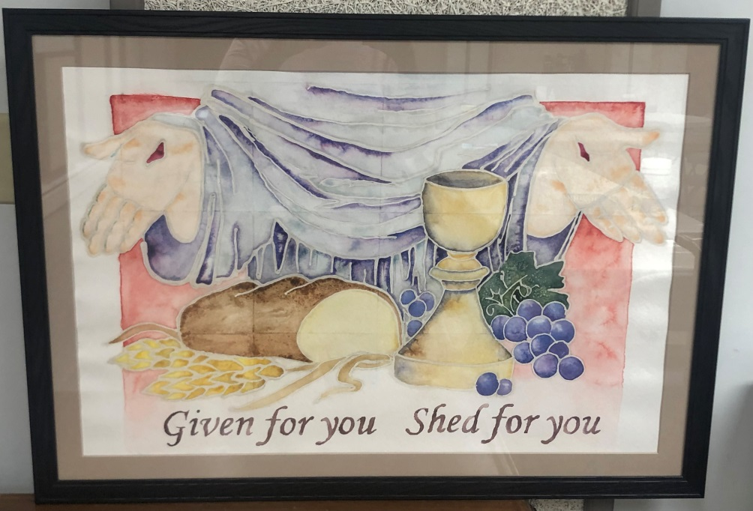

First Mennonite Church of Christian

Moundridge, KS

A welcoming Community of Christians for Peace

January 15, 2023

PRAYER PLACES/JOYOUS JOURNEYS

Prayers for Sheryl Stucky as she continues on Hospice.
Prayers for Bev Zerger and Joe along with Todd and Neil and their families.
Prayers Caryl Tieszen and her brother-in-law who has been diagnosed with terminal cancer. Also prayers for her sister who has been put in the nursing home and doesn’t understand why.
Prayers for Glenn and Pat Stucky. During this past year Glenn and Pat have had many health issues. Pray for a better, healthier 2023. If you have questions contact Rita Stucky.
Prayers for Elizabeth and her doctors, as she continues on her health journey.
Prayers for Connie Germeroth. She had total knee replacement surgery on Tuesday. She is home recuperating and doing well.
Pray for the war-torn countries and their many victims. Pray for peace.
Pray for the flood victims on the west coast and those in the south affected by tornadoes.
Pray for those along our borders who are seeking a better life.
Hopefully you realize that every day is a fresh start for you. That every sunrise is a new chapter in your life waiting to be written.

If you have prayer requests or items of joy, contact one of the Care Team members so we can add those requests as needed. Members are: Pat Krehbiel, Dwight Goering or Cheri Kaufman.

Opportunities

Today: 9:30: Sunday School
10:30: Worship Service

January 17 –January 31: Pastor Pete in New York
January 22: Kevin Wilder will speak in our church
January 25: Deacons, 1:30 pm
Church Board, 7:30 pm
January 29: Ann Zerger will speak during the service
April 14 & 15: KS MCC Sale in Hutchinson, KS

Sunday, January 22: Organist – Bev Hasan, Worship Leader – Lurline Wiens, Special Music – Old Hymn, Guest Speaker – Kevin Wilder

…racism teaches too many people that their lives have not been created by God and that they are not children of God. And if I believe that about you it is easy to believe about myself. That’s what Wendell Berry calls the hidden wound, the hole down in the middle of the soul of America.
- James M. Lawson Jr., Revolutionary Nonviolence, p68

Announcements

Those wishing to communicate with Elizabeth Evans may do so at: gelizae67114@gmail.com
Mailing address is:
101 S. Main Street
Newton, KS 67114
WANTED — Cars, Trucks, Motorcycles, RVs, Campers, Tractors, Modern Farm Equipment, etc. for the Kansas MCC Sale. Items you no longer need can help Feed and Clothe thousands in desperate living conditions. ALL donations are Tax Deductible. Call Jerry Toews for info: 620 367 8257. Help make a difference.

Bethel College Annoucements:
Mon., Jan. 16 – Bethel College celebration of the Martin Luther King Jr. holiday, featuring Dr. Marché Fleming-Randle from Wichita State University, “Together We Can Be THE Dream,” 7 p.m., Memorial Hall
Sun., Jan. 22 – Bethel College Music Department Honors Recital, 4 p.m., Administration Building chapel, featuring freshman, sophomore and junior vocal and instrumental students who performed exceptionally during the fall 2022 semester.
Sat., Jan. 28 – Kauffman Museum annual Kansas Day event, “Kansans Create!,” noon-4 p.m., museum parking lot and grounds (corner of Main & 27th Streets, North Newton). Featuring local artists and artisans, a community art project, food trucks and much more. For more information, see the Kauffman Museum Facebook page or kauffmanmuseum.org

Hesston College Announcements:
January 15 - Lindsay Lou: Join the Dyck Arboretum January 15 at 4 p.m. to hear Lindsay Lou. She is a singer, songwriter, musician, and performer who demands the listener’s attention. Crust & Crumb will serve sweet and savory treats during intermission. Learn more at dyckarboretum.org/events.
January 23 - Nature Book Club: Join the Dyck Arboretum January 23 at 6:30 p.m. via Zoom to participate in their Nature Book Club. Books this month will be “How the Penguins Saved Veronica” by Hazel Prior and “Horizon” by Barry Lopez. Register and learn more at dyckarboretum.org/events.
January 29 - The Barefoot Movement: Join the Dyck Arboretum January 29 at 4 p.m. to hear The Barefoot Movement. They are an acclaimed Americana group that has carved out a space in the acoustic scene. Crust & Crumb will serve sweet and savory treats during intermission. Learn more at dyckarboretum.org/events.
January 31 - Attracting Bees & Beneficial Insects with Native Plants: Join the Dyck Arboretum January 31 at 7 p.m. via Zoom to be a part of their presentation Attracting Bees & Beneficial Insects with Native Plants. Heather Halm will present. Register and learn more at dyckarboretum.org/events..

