First Mennonite Church of Christian
Pastor Laura Goerzen, Organist–Roberta Gingerich, Greeters–Ann and Andy Storer, Worship Leader–James Allen
December 23, 2018

Gathering and Praising
Prelude
Lighting of the Advent Candle
Welcome
Announcements
Opening Prayer
*Gathering Hymn – Hark the Glad Sound! #184
Gospel Reading John 3:16-17
Special Music Laura Goerzen
Epistle Reading 1 Corinthians 12:4-11

Receiving God’s Word
Narnia Story-telling: “Father Christmas”
Coloring Invitation
Sermon – “Gifts from God” Pastor Laura

Hymn of Response – Love came down at Christmas #208

Sharing with One Another
Sharing Joys and Concerns
Prayer of the Church
Offertory
Offertory Prayer

Going in God’s Name
*Sending Song - Infant Holy, Infant lowly #206
*Benediction
Postlude
*Those who are able are invited to stand

Pastor Laura Goerzen
Pastor Laura’s email: laura.n.goerzen@gmail.com
Pastor Laura’s Cell Phone: 620-386-0518
Pastor’s office Hours: Tues.—Fri. 9:30AM-1:30PM
Study Phone 620-345-8766
Church Secretary: Lurline Wiens
Lurline’s phone number: 620-345-2187
Lurline’s email: fmcc.secretary1@gmail.com
Office hours: Tues. 1:00-4:00PM, Thurs-Fri. 8:30AM-12:00pm
Church Phone: 620-345-2546
Church Website: www.fmccmoundridge.org

Gifts from God
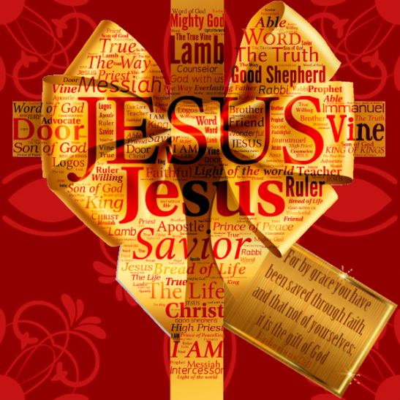

First Mennonite Church of Christian
Moundridge, KS
A welcoming Community of Christians for Peace
December 23, 2018

Announcements
Opportunity to Gift Cradle to Crayons with Christian Resources: Cradle to Crayons provides loving childcare for the youngest members of our community and is developing a fresh supply of Christian resources to aid in its ministry to these young children. If you would like to give the gift of introducing young children to God’s love, go towww.amazon.com and hover over the Account & Lists icon. Click on “Find a List or Registry” and search for Cradle to Crayons. You will find a wish list of high quality faith-based toys and children’s books from which to choose a gift for our local childcare center.
The Neuf Memorial Run: The Neuf 9K and 2 mile run returns to the campus of Bethel College on Jan. 12, 2019 to honor the memory of Russ Neufeld, a former MC USA and Hesston College employee. The race will start at 10AM outside of Mojo’s Coffee Shop on the campus of Bethel College, North Newton, KS. The Neuf will raise funds for the Leukemia and Lymphoma Society, and the Russ Neufeld Memorial Scholarship at Hesston College. Register and read other details about the race at www.runtheneuf.neuf.ca. We would love to have you join us for this fun community event!
Associated Ministries of Moundridge selling coffee: This holiday season the Associated Ministries of Moundridge will again be selling coffee grown in Honduras by the family of Moundridge native Julia Niehage Williams. This specialty coffee is available in 1 lb. bags of either whole bean or ground and would make great Christmas gifts or would be perfect to serve at holiday dinners or parties. The coffee sales will support the work of the Associated Ministries of Moundridge and the ministries they serve. The project was kicked off at the Moundridge Chamber of Commerce Craft Show and Continues through the month of December. Please contact Rick Krehbiel at 620-386-4147 if you have any questions
Kaufman Museum: is open through the holidays (closed Mondays, plus Christmas Day and New Year’s Day): hours 9:00AM-4:30PM weekdays, Sat-Sun., 1:30-4:30PM. Visit the current special exhibit “Better Choose Me: Collecting and Creating with Tobacco Fabric Novelties, 1880-1920,” featuring the collection of the late Ethel Ewert Abrahams. See ww.bethelks.edu/Kauffman/ or the Kauffman Museum Facebook page for more information.
Thank you: Thank you to all of you for the prayers, visits, the encouraging cards and e-mails. Also for the wonderful food brought in. May God bless you all. Marvella and Marlan
Ride needed: A church member needs a ride to a doctor’s appointment in Westwood, KS (Kansas City area), on December 28, at 1:30PM. If you would like more information about this opportunity to provide transportation assistance, talk to Pastor Laura.
Delivering Meals: January is FMCC’s month to deliver Senior Center meals. There is a sing-up sheet on the south wall in the foyer. Please take a look at that and sign up when you can help. You get a free meal if you want one for delivering the meals. You pick then at 11:00AM at the Center. Currently it takes about 45 minutes. Right now we are delivering one 8 miles out of town. That takes some extra time. If you have questions contact Pat Krehbiel. Please consider helping
New in the library: “Someone New”, Anne Sibley O’Brien
“All Are Welcome”, Alexandra Penfold
“We Are Brothers, We Are Friends”, Alexandra Penfold
Office closed: The church office will be closed Chirstmas Eve Day, Christmas Day, New Years Eve Day and Near Years Day.
Thank you received: WDC ‘s Church Planting ministry thanks you FMCC congregation for your recent special offering. It will go towards empowering congregations to Witness to others in Jesus Christ, Dwell in just and loving relationships and connect to God’s mission in the world.
Centering Prayer will not meet Monday, December 24 or Monday, December 31, but will resume Monday, January 7, 2019. Centering Prayer meets from noon to 1:00PM most Mondays at the Agape Center in Richert House on the Bethel College campus and is open to anyone, regardless of previous experience. For more informationn, contact Melanie Zuercher, mzuercher@bethelks.edu, or Nathan Koontz, Nathan@hutchfmc.org.

Monday, December 31: The Bethel College advancement/development office invites you to a holiday open house, 9:00AM- 3:00PM. Come by to visit with staff, enjoy holiday treats and a warm beverage – and make your year-end donation. The office is on the main floor of the Administration Building on campus.

Sunday, January6, 2019: Rachel Pannabecker presents “Remembering Ethel Ewert Abrahams, Collector and Artist,: a Sunday-Afternoon at the Museum program, 3:00PM, Kaufman Museum. Pannabecker will talk about Abrahams’ unusual collection of tobacco fabric novelties, which she believes to be the largest in the United States, and which is now on display as the museum’s special exhibit.

Opportunities
Today: 9:15AM First Perk
9:30AM Sunday school
10:30AM Worship Service
December 23: Christmas Eve program practice 11:30 pizza lunch with practice to follow
December 24: Christmas Eve Service 7:00PM
December 29-January 2: Pastor Laura out of the office
December 30: Christmas Carol sing led by Steve Kaufman
January 10, 2019: Worship Team 9:30AM
January 12, 2019: Neuf Memorial Run
January 16, 2019: Church Board Meeting 8:00PM
Sunday December 30: Organist –Lu Goering, Greeter- Ann and Andy Storer, Worship Leader – Lurline Wiens, special music – Gin Niehage & Steve Kaufman

We seek and practice Shalom
For to us a child is born, to us a son is given, and the government will be on his shoulders. And he will be called Wonderful Counselor, Mighty God, Everlasting Father, Prince of Peace. Isaiah 9:6

