First Mennonite Church of Christian
Pastor Laura Goerzen, Organist–Lu Goering, Greeters–Darwin & Jodi Gingerich, Worship Leader–James Allen
January 27, 2019

Gathering and Praising
Prelude
Welcome
Announcements
Opening Prayer
*Gathering Hymn – Come, ye disconsolate #497
Reading the Psalms together Psalm 6
1 LORD, do not rebuke me in your anger or discipline me in your wrath
2 Have mercy on me, LORD, for I am faint; heal me, LORD, for my bones are in agony.
3 My soul is in deep anguish. How long, LORD, how long?
4 Turn, LORD, and deliver me; save me because of your unfailing love.
5 Among the dead no one proclaims your name. Who praises you from the grave?
6 I am worn out from my groaning. All night long I flood my bed with weeping and drench my couch with tears.
7 My eyes grow weak with sorrow; they fail because of all my foes.
8 Away from me, all you who do evil, for the LORD has heard my weeping.
9 The LORD has heard my cry for mercy; the LORD accepts my prayer.
10 All my enemies will be overwhelmed with shame and anguish; they will turn back and suddenly be put to shame.
*Congregational Hymn – When the storms of life are raging #558
Scripture Reading Psalm 12

Receiving God’s Word
Coloring Invitation
Sermon – “Lord, hear my cry!” Laura Goerzen
Hymn of Response – When peace, like a river #336

Sharing with One Another
Sharing Joys and Concerns
Prayer of the Church
Offertory
Offertory Prayer

Going in God’s Name
*Sending Song - In your sickness #585
*Benediction
Postlude

*Those who are able are invited to stand

Pastor Laura Goerzen
Pastor Laura’s email: laura.n.goerzen@gmail.com
Pastor Laura’s Cell Phone: 620-386-0518
Pastor’s office Hours: Tues.—Fri. 9:30AM-1:30PM
Study Phone 620-345-8766
Church Secretary: Lurline Wiens
Lurline’s phone number: 620-345-2187
Lurline’s email: fmcc.secretary1@gmail.com
Office hours: Tues. 1:00-4:00PM, Thurs-Fri. 8:30AM-12:00pm
Church Phone: 620-345-2546
Church Website: www.fmccmoundridge.org

Psalms of Lament
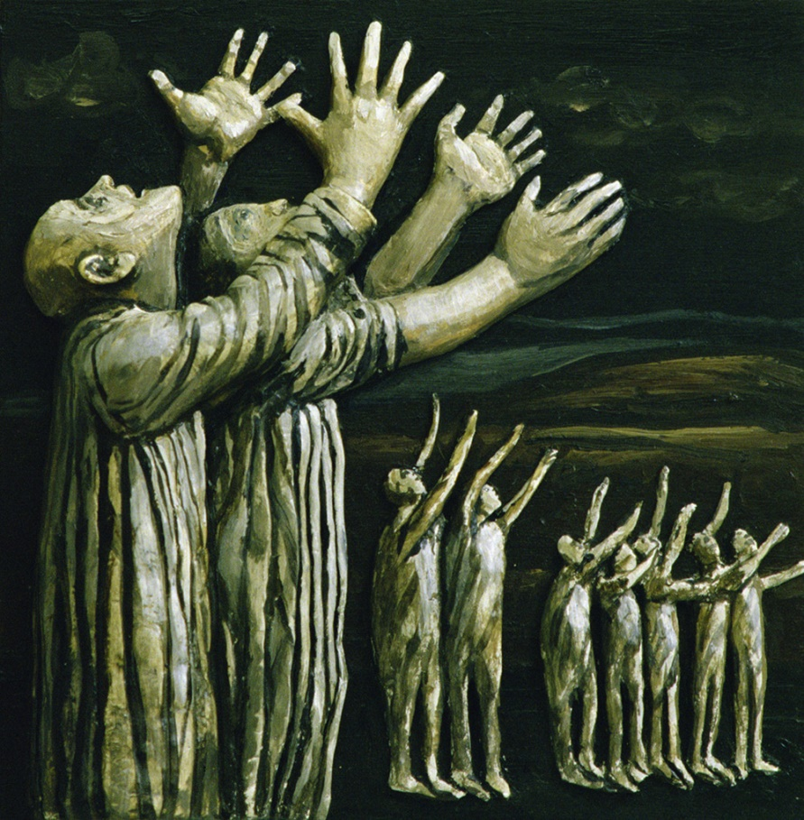
First Mennonite Church of Christian
Moundridge, KS
A welcoming Community of Christians for Peace
January 27, 2019

Announcements
Members names and addresses list: In order to start getting ready for the yearbook, the member address list is on the south table in the foyer. Please check to make sure all of your info and your children’s is correct. If you know of another name/address that needs correction, please make that correction on the sheet also. Thank you.
Join us for an MCC Lunch & Learn: with John Sharp on Wednesday, January 30 from 12-1PM at MCC in North Newton (121 E. 30th St.): John will share his presentation, “Changing the World One Life at a Time: the MJ Sharp Story”. MJ and his colleague Zaida Catalán, part of a U.N. panel of experts investigating conflicts that have been ongoing in Congo since the mid-1990s, were abducted and killed in March 2017. MJ served with MCC in the Congo prior to his work with the U.N. John is passionate about telling MJ's story and he and his wife Michelle's journey with him. John will also share updates to the investigation that is ongoing in Congo. Please RSVP to this event by January 25 to patsydirksen@mcc.org. Lunch will be catered by Mojo’s Coffee Bar, please list food sensitivities when you RSVP.
Favorite Psalms from the congregation: Laura will be starting a series on the Psalms Sunday January 20. She would like to include your favorite Psalms in her series. Please let her know your favorite Psalms or a story about your favorite Psalms as soon as you can, so it can be included in the 5 week series.
Honor Band & Honor Orchestra: Saturday, February 2, 2019, the 2019 High School Honor Band and Honor Orchestra joint concert at 7:00PM in Memorial Hall on Bethel College Campus.
February 3 is Mennonite Education Sunday at West Zion! Patty Shelly, Bible Professor at Bethel College, will lead adult Sunday School on the gospel of Luke, and preach. Russell Adrian will lead the Bel Canto choir from Hesston. Donna Stucky and Ken Rodgers are planning special music. We will have a potluck meal after worship. Plan to bring a dish to share!

A special thank you: to Rick Krehbiel, Ferd and Lurline Wiens, Jerroll and Carol Goebel, Loren and Karen Unruh, Darrell and Peggy Bissing and Dale Germeroth for delivering meals for the Senior Center during the month of January. You not only delivered them a nice hot meal, you visited with them. You might have been the only person they saw all day. We at the Center appreciate your volunteering. Thank you!
Starting a new service: FMCC would like to start a new service for our church family members. On cold wintery months, it is difficult for some individuals to park their cars in the parking lot and get into church safely. We are looking for individuals who might be willing to be available on Sunday morning to help those who might need assistance. These would be the times that your service would be needed: prior to Sunday School and prior to the church service hour and again following the end of the service. If we can get several individuals to help, no one will have to do it too many times a month. Please give this prayer full consideration. Contact Pat Krehbiel if you can help.
Saturday February 2: Kauffman Museum first-Saturday Bird Wall. Meet at 8:00AM in the museum parking lot, corner of Main and 27th streets, North Newton – experienced birders will lead a walk of 1 to 1.5 hour. Please be aware this is mostly on an unpaved trail and the terrain is sometimes sloping or steep.
Sunday, February 10: Organ Recital Series: Ken Walker, 4:00PM, Administration Building chapel at Bethel College.
The MCC Comforter Blitz Committee: is urgently seeking a kitchen coordinator and volunteers to prepare and serve lunch during the Blitz (March 4th, 5th, and 6th, 2019). If you are interested or willing, please contact Shirley Jost at (785) 250-7437 or jostshi@cox.net. No sewing skills required!

MCC Sale Opportunities:
Looking for your donations of old cars, trucks, tractors, motorcycles, mowers and most ANYTHING of value for the KS MCC Sale this coming April. If you are thinking of buying a new car, consider donating your old car to the MCC Sale. We will pick them up, clean them up, and get them running. Your donations can change people’s lives and give them hope. Call Jerry Toews 620-367-8257.
Dear friends of the Kansas Mennonite Relief Sale, You’re invited to host, be a guest or organize a fellowship meal at your church. Annually, these simple meals help support the Relief Sale by raising funds towards the sale budget. Meals in area homes are scheduled for March 3 & 10. Registration deadline is Feb. 8. Please Contact Ferd Wiens for Fellowship Meals forms or any questions you may have

Quilters’ Corner Opportunities: Volunteers are welcome and needed each Tuesday evening 7-9PM at the MCC Center in North Newton to help sort and price items for the Sale as well as each third Saturday of the month (Jan 19, Feb 15, March 15) any time between 9AM – 3PM. Quilting donations are also welcome and needed i.e. quilting fabrics, quilting supplies, vintage linens, unfinished quilting projects, etc. Donations may be collected by Sale liaisons at their churches and brought to Sale meetings or brought directly to the MCC Center with the indication that they are for Quilters’ Corner. If you have questions contact Ann Yoder Smith, 919-604-3282, rws.ays@gmail.com.

List your quilt in the KS Menno Relief Sale Quilt Auction Buyer’s Guide. Deadline is March 11. Please deliver your quilt, comforter or quilt related item to a quilt committee member or to a Relief Sale meeting or take to the MCC Center in North Newton. Quilt forms are available online at kansas.mccsale.org. For more information check with Ferd Wiens or quilt committee members, Jan Diller at 620-217-1704 or Charlene Driggers at 620-947-1749.

Opportunities

Today: 9:15AM First Perk
9:30AM Sunday school
10:30AM Worship Service

February 3: Mennonite Education Sunday at West Zion, potluck following. All Sunday school ages meet at West Zion.

February 7: Worship Team Meeting, 9:30AM

February 10: Communion Sunday

February 11: Friendship Circle Salad Luncheon, 12:00PM

February 14-17: Pastor Laura traveling

February 17: Guest speaker Eric Schrag of Prairie View

February 27: Deacons Meeting, 7:00PM, Board Meeting, 8:00PM

March 3: Worship at Pine Village, 10:30AM

April 12 & 13: KS MCC Sale

We seek and practice Shalom
You are blessed when you stay on course, walking steadily on the road revealed by God. You’re blessed when you follow his directions, doing your best to find him.
Psalm 119: 1-2, The Message

