First Mennonite Church of Christian
Pastor Laura Goerzen, Organist – Hazel Voth, Greeters – Rick & Pat Krehbiel, Worship Leader – Caryl Tieszen
March 1, 2020

Gathering and Praising
Prelude
Welcome
Announcements
Call to Worship
Leader: Eternal God, you call beloved daughters and sons.
People: We praise you for creating us and calling us to cultivate your life in the world.
Leader: Eternal God, you call our name in the garden.
People: We come to worship, acknowledging our vulnerabilities and temptations.
Leader: Eternal God, you are our hiding place, where forgiveness and mercy encircle us.
ALL: Thanks be to God for the radical grace offered to us through Jesus Christ.
*Gathering Hymn–“Come, thou fount” #521
Lenten Scriptures: Genesis 2:15-17, 3:1-7; Psalm 32; Romans 5:12-19; Matthew 4:1-11 Caryl Tieszen & Pat Goering
Special Music – “In Christ Alone” (recording) Stuart Townsend

Receiving God’s Word

Meditation Laura Goerzen
Prayer of Confession
Leader: God calls to us, “Where are you?”
People: We, like Adam, hide in the garden, hoping God does not come looking for us.
Leader: God asks, “What have you done?”
People: We, like Eve, say, “The devil made me do it,” masking our shame.
Leader: Our choices have consequences and yet God’s grace abounds.
People: I confess I have hidden and denied my sin. When I refused to admit my wrongs, I was miserable; even my bones felt brittle. Lord have mercy. Christ have mercy. (silence)
Ritual of Response
Sharing with One Another

Sharing Joys and Concerns
Hymn of Preparation – “Put peace into each other’s hands” STJ # 87, v. 1, 3-4
Sharing the Lord’s Supper
Prayer of the Church
Offering
Offertory Prayer
Going in God’s Name

*Sung Benediction – “Change my Heart O God” CCLI #11225002
*Benediction
Postlude

*Those who are able are invited to stand

Pastor Laura Goerzen
Pastor Laura’s email: laura.n.goerzen@gmail.com
Pastor Laura’s Cell Phone: 620-386-0518
Pastor’s office Hours: Tues.—Thurs. 9:30AM-1:30PM,
Fri. 1:00-4:30PM

Study Phone 620-345-8766
Church Secretary: Lurline Wiens
Lurline’s phone number: 620-345-6657
Lurline’s email: fmcc.secretary1@gmail.com
Office hours: Tues. 1:00-4:30PM, Thurs-Fri. 8:30AM-11:30am
Church Phone: 620-345-2546
Church Website: www.fmccmoundridge.org

Please pray for the deteriorating situation on Lesvos and the other Greek islands. Apart from the new asylum law, which is stricter and which the government began implementing in January, the central government is also pushing through its plan to build closed detention centers for migrants on the Greek islands, in spite of the regional government, local governments and local Greek people protesting.

Lent 1: Show us your hiding place in the thick of temptation

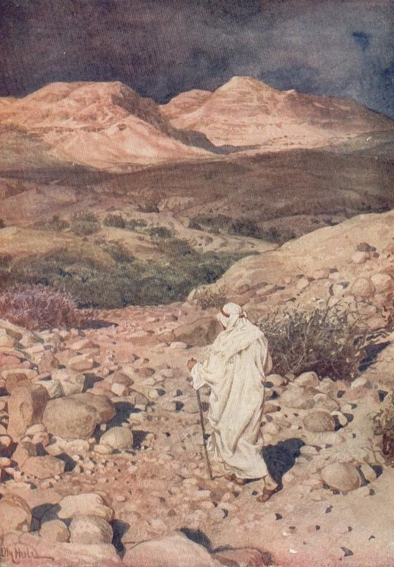
First Mennonite Church of Christian
Moundridge, KS
A welcoming Community of Christians for Peace
March 1, 2020

Opportunities
Today: 9:30 Sunday School
10:30 Worship Service
March 2: Library meeting, 7:00 pm
March 5: Worship Team, 9:30am
March 7: STEPS Training in our church, 9:00 am – 4:00 pm
March 8: Baby Shower/Potluck Dinner for Cris & Shenise Weimer, 11:30 am
March 9: Caring and Sharing, 2:00 pm
March 11: Education Committee, 7:00 pm
March 16-22: Pastor Laura out of office
March 22: Guest Speaker Lee Suderman
March 24-26: Pastor Laura out of office
March 28: Church Work Day
April 5: Community Passover Meal and Communion, 6:00PM FMCC Fellowship Hall
April 6: Community Holy Week Service, 7:00PM FMCC Sanctuary

Sunday, March 8: Organist – Roberta Gingerich, Greeters – Rick & Pat Krehbiel, Worship Leader – John Goerzen, Special music – James & Lynette Allen

“When will justice come to Athens?” they asked Thucydides. He answered, “Justice will not come to Athens until those who are not injured are as indignant as those who are.

Announcements

Where is the prayer quilt? The prayer quilt is back at church.
Welcome a new baby boy! Let’s celebrate with Cris and Shenise Weimer with a Baby Shower/Potluck dinner on Sunday, March 8 at 11:30 am.
March Library Meeting, Monday, March 2, 7:00 pm.
New Purple Hymnals: The worship team has decided to order 60 new Purple Hymnals for next fall. We have some of the money to cover the cost already. In order to help cover the rest of the cost and maybe the cost of the projection hymnal, if you want to give to this project, during the month of March if you would write on your check in the memo line how much you would like to give to the cost of the hymnals, that will go towards them. We will only do this during the month of March. If you have questions, please direct them to Lurline Wiens.
Sunday, March 8, we will start “The Coins Count” program, collecting spare coins for MCC. Check under your sofa cushions and all other hiding places and bring your spare change to be collected by the kids.
A special thank you to all who donated food for the FEWZ feeding the soup kitchen in Hutch last Saturday. We are sorry the food was not picked up, but appreciate your donating and will work to make food delivery arrangements clearer in the future. The FEWZ
The Moundridge Food Pantry is looking for an individual to become its Director as they serve those families and individuals in need in our community. If you have any interest or questions, please contact Rick Krehbiel at 620-386-4147.
Mobility Worldwide/PET is going on a Guatemala distribution March 30 to April 6, 2020. If anyone would like to help with in country expenses, like distribution of carts, or special projects helping the poor, send checks to Mobility Worldwide, 320 Ruth St., Moundridge. – Kirby and Chris

SAVE THE DATE! -- Mark your calendars for the Western District Women in Mission Spring Supper at 6 pm on Thursday, March 12 at Faith Mennonite Church, Newton, KS. Our Special Guest Speaker will be Patty Shelly, Professor of Bible and Religion at Bethel College. Additional information coming soon!
You are invited to join the fun at the 13th annual MCC Comforter Blitz on March 2, 3 and 4 at Journey Mennonite Church at the Yoder Campus, one mile north of Yoder, Kansas. Blitz times are Monday and Tuesday, 9:00am to 5:00pm, and Wednesday, 9:00am to 4:00pm. This event is hosted by Kansas Friends of MCC, an organization that supports the work of MCC. For more information check out mcc.org/comforter-blitz.
Dr. James Juhnke will be the speaker at the March 8 annual meeting of the Swiss Mennonite Cultural and Historical Association held at 2:30 p.m. in the Fellowship Hall at Bethel College Mennonite Church. “Mennonite Museum in Uzbekistan” is the title of the presentation. He will tell about the history of the Mennonite community that lived for fifty years near the city of Khiva, and how that community is now celebrated in a new museum in Khiva. He will address why the Mennonites moved to a Muslim area and why the Muslims there created a museum that remembers the Mennonites. The Handbell Choir of the Bethel College Mennonite Church will provide music. Election of SMCHA officers for 2020 will be held and there will be an opportunity for members to give counsel and ask questions. Refreshments will be served. No reservations are needed.
Seeing Each Other's Light, a program of story and song that provides understanding of diverse people, cultures and faith traditions of the Wichita community, will be held at Emanu-El Congregation Reform Synagogue, 7011 E. Central Ave., Wichita, 4 p.m. on Sunday, March 1. The event is part of Hesston College's Peacing It Together Foundation and is also sponsored by Wichita's Global Faith in Action. The program features Hesston College students and internationally-acclaimed baritone Tony Brown, as well as other members of the Wichita community, including the Emanu-El Klezmer band and congregation choir. The concert is free and open to the public. For the full news release, go to www.hesston.edu.
Hesston College Music and Theatre will present six performances of the musical Tuck Everlasting in the Keim Center Black Box Theater. Show times are 7 p.m. March 4 to 7, with an extra 2 p.m. show on March 7, as well as a 2 p.m. showing on March 8. Tickets are $12 for adults and $5 for students. Seating is limited so advanced ticket purchase is encouraged at hesston.edu/bookstore or by calling 620-327-8105. Tuck Everlasting is family-friendly and rated G, but due to length is recommended for ages 7 and up.
Bethel College Announcements:
Sat., March 7 – Kauffman Museum First-Saturday Bird Walk. Meet at 7:30 a.m. in the museum parking lot, corner of Main and 27th streets, North Newton – experienced birders will lead a walk of 1 to 1.5 hours. Please be aware this is mostly on an unpaved trail and the terrain is sometimes sloping or steep. Mon., March 9-Fri., March 13 (one week only) – “Secrets of an Inner World,” miniature painting by Ayesha Durrani, Regier Art Gallery in Luyken Fine Arts Center at Bethel College; weekday hours 9 a.m.-5 p.m. Tues., March 10 – artist talk by Ayesha Durrani, followed by a reception for “Secrets of an Inner World,” 7 p.m., Administration Building chapel and Regier Art Gallery in Luyken Fine Arts Center at Bethel College. Thurs., March 12, Fri., March 13, Sat., March 14 – Bethel College spring musical: The Theory of Relativity by Neil Bartram and Brian Hill, 7:30 p.m., Krehbiel Auditorium in Luyken Fine Arts Center; tickets in Thresher Shop in Schultz Student Center, weekdays 8 a.m.-5 p.m., or at the door, subject to availability. Content warning: rated PG-13 for adult themes and language.

