First Mennonite Church of Christian
Pastor Laura Goerzen, Organist – Roberta Gingerich, Greeters – Rick & Pat Krehbiel, Worship Leader – John Goerzen
March 8, 2020

Gathering and Praising
Prelude
Welcome
Announcements
Call to Worship
Leader: We lift up our eyes looking for help.
People: Our help comes from the Lord who made heaven and earth.
Leader: When we have troubles and difficulties, where does our help come from?
People: Our help comes from the Lord who made heaven and earth.
Leader: When we are invited into new ways of thinking and being, where does our help come from?
People: Our help comes from the Lord who made heaven and earth.
ALL: Let us worship the one who faithfully helps us and never leaves us or forsakes us.
Opening Prayer
My coins Count
*Gathering Hymn–“To God be the Glory” #102
Lenten Scriptures: Genesis 12:1-4a; Psalm 121; Romans 4:1-5; John 3:1-17 John Goerzen, Tim Graber
Special Music –

Receiving God’s Word

Meditation Laura Goerzen
Prayer of Confession
All: We confess, O God, that you are faithful, loving, and totally trustworthy. We acknowledge that you sometimes call us to accept new challenges, new ways of thinking, or new places of service. Lord, give us the grace to respond to your call when you invite us into new ways of being.
Leader: Friends, the One who calls us is the faithful one who promised to never leave us or forsake us. May know God’s presence more fully.
All: Thanks be to God.
Ritual of Response
Hymn of Response – “Will you come and follow me” STJ #39
Sharing with One Another

Sharing Joys and Concerns
Prayer of the Church
Offering
Offertory Prayer
Going in God’s Name

*Sung Benediction – “Change my Heart O God” CCLI #11225002
*Benediction
Postlude

*Those who are able are invited to stand

Pastor Laura Goerzen
Pastor Laura’s email: laura.n.goerzen@gmail.com
Pastor Laura’s Cell Phone: 620-386-0518
Pastor’s office Hours: Tues.—Thurs. 9:30AM-1:30PM,
Fri. 1:00-4:30PM

Study Phone 620-345-8766
Church Secretary: Lurline Wiens
Lurline’s phone number: 620-345-6657
Lurline’s email: fmcc.secretary1@gmail.com
Office hours: Tues. 1:00-4:30PM, Thurs-Fri. 8:30AM-11:30am
Church Phone: 620-345-2546
Church Website: www.fmccmoundridge.org

Please pray for Wet’suwet’en land defenders and their allies in the lands known as Canada. For years, Wet’suwet’en hereditary chiefs have led nonviolent resistance to the construction of oil and gas pipelines across their unceded land, which lies between the Alberta tar sands and the port of Kitimat on the west coast. The proposed pipelines would allow for the expansion of the Alberta tar sands, already considered the largest and most destructive industrial project in the world.

Lent 2: Show us your faithful, loving presence

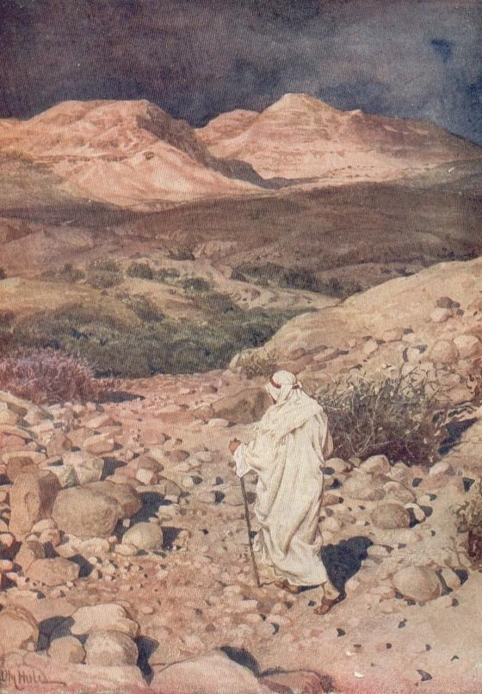
First Mennonite Church of Christian
Moundridge, KS
A welcoming Community of Christians for Peace
March 8, 2020

Opportunities
Today: 9:30 Sunday School
10:30 Worship Service
March 8: Baby Shower/Potluck Dinner for Cris & Shenise Weimer, 11:30 am
March 9: Caring and Sharing, 2:00 pm
March 11: Education Committee, 7:00 pm
March 16-22: Pastor Laura out of office
March 22: Guest Speaker Lee Suderman
March 24-26: Pastor Laura out of office
March 28: Church Work Day
April 5: Community Passover Meal and Communion, 6:00PM FMCC Fellowship Hall
April 6: Community Holy Week Service, 7:00PM FMCC Sanctuary
April 10: Prayer stations
April 12: Easter
April 17 & 18: MCC Sale
Sunday, March 15: Pianist – Lu Goering, Greeters – Bob & Caryl Tieszen, Worship Leader – James Allen, Special music – Steve & Cheri Kaufman

6 “I, the Lord, have called you in righteousness;
I will take hold of your hand.
I will keep you and will make you
to be a covenant for the people
and a light for the Gentiles,
7 to open eyes that are blind,
to free captives from prison
and to release from the dungeon those who sit in darkness.
- Isaiah 42: 6-7

Announcements

Where is the prayer quilt? The prayer quilt is back at church.
New Purple Hymnals: The worship team has decided to order 60 new Purple Hymnals for next fall. We have some of the money to cover the cost already. In order to help cover the rest of the cost and maybe the cost of the projection hymnal, if you want to give to this project, during the month of March if you would write on your check in the memo line how much you would like to give to the cost of the hymnals, that will go towards them. We will only do this during the month of March. If you have questions, please direct them to Lurline Wiens.
Sunday, March 8, we will start “The Coins Count” program, collecting spare coins for MCC. Check under your sofa cushions and all other hiding places and bring your spare change to be collected by the kids.
Mobility Worldwide/PET is going on a Guatemala distribution March 30 to April 6, 2020. If anyone would like to help with in country expenses, like distribution of carts, or special projects helping the poor, send checks to Mobility Worldwide, 320 Ruth St., Moundridge. – Kirby and Chris
The 7th Annual Benefit Day Pulled Pork and Baby Back Ribs Dinner will be Saturday, March 28th from 5-6:30 p.m. in the Pine Village Wellness Center. Friends and family are welcome to come enjoy, tender, smoked pulled pork and fall off the bone baby back ribs. You’re not going to want to miss this! Baby back ribs by the rack and pulled pork by the pound are also available for pre-order. All pre-orders are due by March 18th and all orders can be picked up the day of the BBQ. Per-order forms are available online at www.pinevillageks.org . So bring your appetite, as we kick off our 2020 Benefit Season! About Pine Village: Pine Village is a non-profit Continuing Care Retirement Community, offering gracious living for adults 62 and older with an active and independent lifestyle for today in a supportive Christian environment. Services include independent living, assisted living, health care, skilled care and memory care. For more information, visit us online at www.pinevillageks.org or come by for a visit at 86 22nd Ave., Moundridge, Kan.

SAVE THE DATE! -- Mark your calendars for the Western District Women in Mission Spring Supper at 6 pm on Thursday, March 12 at Faith Mennonite Church, Newton, KS. Our Special Guest Speaker will be Patty Shelly, Professor of Bible and Religion at Bethel College. Additional information coming soon!
Mennonite Healthcare Fellowship (MHF) is seeking a half-time Executive Director to start between May and September 2020 who is committed to Anabaptist values and the mission of MHF, has proven skills in administration, communication, and networking, and has an intergenerationally compelling vision for MHF. Interested persons are invited to send a resume and statement of intent, including the broad strokes of your vision and thoughts about a strategic plan, to president@mennohealth.org. More information at www.mennohealth.org.
MCC Sale Announcements:
Get ready for the Kansas Mennonite Relief Sale on April 17 & 18, 2020 at the Kansas State Fairgrounds in Hutchinson. What can you bring as your gift to the hungry and hurting at home and abroad? Quality woodwork and needlework items, cotton tea towels, hobby items, crafts, plants and baked foods are much in demand. Donate items for the General, Silent and Children’s Auctions. We call upon quilters to complete their quilts and to gather extra supplies to donate to Quilters’ Corner. Begin to divide house plants and start vegetable plants to sell at Plants &Things and tea towel sets for Kansas Crafts. Participate in the Run for Relief, a 5K run/walk, the Saturday of the sale and gather pledges. Stay up-to-date on all things relating to Kansas Mennonite Relief Sale by liking us on Facebook at Kansas Mennonite Relief Sale or our website at www.kansas.mccsale.org If you have pictures of items you are donating, send to photos@kansas.mccsale.org to items can be advertised online.
Service Opportunities at KMRS: The Kansas Mennonite Relief Sale invites you to join our family. There is variety of committee openings including an Urgent Need for a Treasurer; Domestic Arts Verenike Booth Committee Members; Feeding the Multitude Sausage Baking Chair on Saturday; Verenike Frying Chair Friday; and New Year’s Cookie committee. See your Relief Sale Liaison for details on these opportunities.
Thousands of Volunteers are needed for the Kansas Mennonite Relief Sale to be a success April 17 & 18, 2020. Sign up to help make New Year’s Cookies; Serve or Wait Tables at Feeding of the Multitude; Sell Plants & Things; Serve Verenike/Sausage in Domestic Arts. Check with your Church Liaison where the need is and how to sign up. Also, sign up to volunteer on line at www.kansas.mccsale.org/volunteer
Bethel College Announcements:
Mon., March 9-Fri., March 13 (one week only) – “Secrets of an Inner World,” miniature painting by Ayesha Durrani, Regier Art Gallery in Luyken Fine Arts Center at Bethel College; weekday hours 9 a.m.-5 p.m. Tues., March 10 – artist talk by Ayesha Durrani, followed by a reception for “Secrets of an Inner World,” 7 p.m., Administration Building chapel and Regier Art Gallery in Luyken Fine Arts Center at Bethel College. Thurs., March 12, Fri., March 13, Sat., March 14 – Bethel College spring musical: The Theory of Relativity by Neil Bartram and Brian Hill, 7:30 p.m., Krehbiel Auditorium in Luyken Fine Arts Center; tickets in Thresher Shop in Schultz Student Center, weekdays 8 a.m.-5 p.m., or at the door, subject to availability. Content warning: rated PG-13 for adult themes and language.
Sat., March 14 – Matthew Garber senior voice recital, 3 pm, Administration Building chapel at Bethel College.

