First Mennonite Church of Christian and
Pianist – Delonna Barnett, Worship Leader – Rita Stucky, Song Leader – Gin Niehage
April 30, 2023

Gathering and Praising

Prelude

Welcome

Morning Prayer

Announcements

Call to Worship
Leader: You who are poor, why have you come?
People: To hear good news.
Leader: You who are brokenhearted, why have you come?
People: To heal our hearts.
Leader: You who are captive, why have you come?
People: To hear words of freedom.
Leader: You who are prisoners, why have you come?
People: To be released from what binds us.
Leader: You who mourn, why have you come?
People: To receive comfort.
Leader: Then you are welcome here in this place,
at this table, where Jesus offers blessing for all.

*Hymn – “To God Be the Glory” VT #81

Scripture – John 10:1-10

Special Music – “Morning Has Broken” VT #495
Rick Krehbiel & Steve Kaufman accompany on guitar

Offering (put your offering in the plate at the back of the church)

Offertory Prayer

Receiving God’s Word

Sermon – “The sheep hear his voice” Pastor Pete Emery

Sharing with One Another

Hymn for Communion – “Let Us Break Bread Together” VT #482

Sharing Joys and Prayer Requests

Celebrating Communion

Prayer of the Church

Going in God’s Name

*Sending Song - “Praise God” VT #70

*Benediction

*Those who are able are invited to stand

Pastor Pete Emery

Pastor Pete’s email: fmcc.pastorpete@gmail.com

Pastor Pete’s Cell Phone: 785-577-1447

Pastor’s office Hours: Monday-Friday 9:00 am-3:00 pm

Study Phone 620-345-8766

Church Secretary: Lurline Wiens

Lurline’s phone number: 620-345-6657
Lurline’s email: fmcc.secretary1@gmail.com
Office hours: Tues. 1:00-4:30PM, Thurs-Fri. 8:30AM-11:30am
Church Phone: 620-345-2546
Church Website: www.fmccmoundridge.org

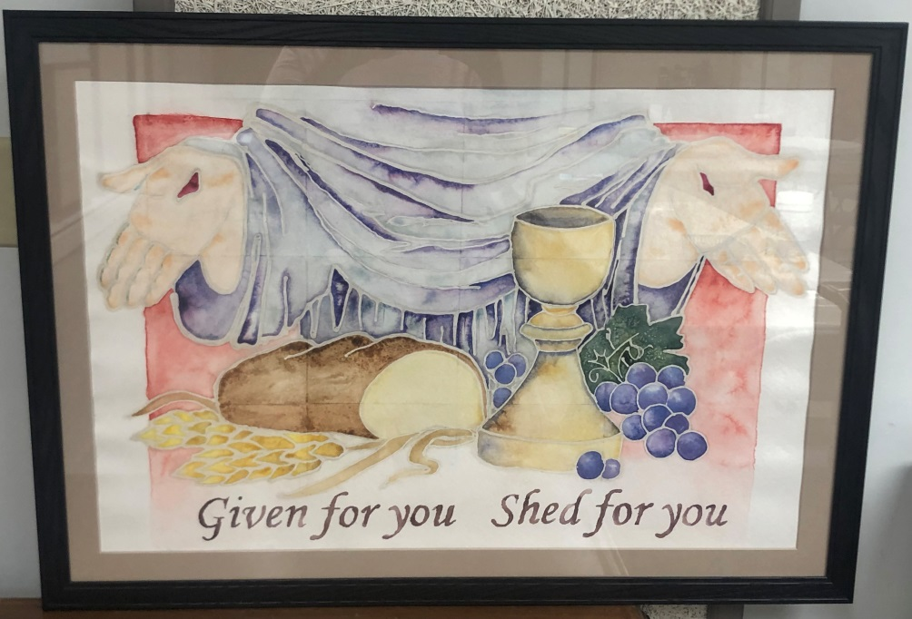

First Mennonite Church of Christian

Moundridge, KS

A welcoming Community of Christians for Peace

April 30, 2023

PRAYER PLACES/JOYOUS JOURNEYS

Pray for Sheryl and Russ Stucky, Sheryl’s health continues to decline.
Jerry and Delores Voth have moved into Assisted Living at Pine Village. Pray for them as they settle into a new chapter in their lives. They are in room 110.
Prayers continue for Lowell Stucky. He is now home and healing from his recent accident.
Pray for the many poverty victims in Sudan with the starving children.
Pray to control shooting violence that continues.

We know that troubles produce endurance, and endurance brings God’s approval, and His approval creates hope.
Romans 5:3-4

If you have prayer requests or items of joy, contact one of the Care Team members so we can add those requests as needed. Members are: Pat Krehbiel, Dwight Goering or Cheri Kaufman.

Opportunities

Today: 9:30: Sunday School
10:30: Worship Service

April 29 & May 1: Pastor Pete at a conference in Hesston, KS
April 30: Communion during the church service
May 3: Worship Team, 9:30 am
May 14: Mother’s Day
May 21: Eric Schrag from Pine Village will speak
June 4: Church Service in the park with pot luck lunch
July 15-16: Camp Mennoscah with Eden Church

Sunday, May 7: Organist – Bev Hasan, Worship Leader – Randy Stucky, Special Music – New Hymn

It is easier to build strong children than to repair broken men.
- Frederick Douglas

Announcements

Graduates: if you have a child, grandchild or great-grandchild that is graduating this year. Please let Lurline know by Thursday, May 11, and she will get that information into the bulletin.

Moundridge Food Pantry is looking for Volunteers! We serve anyone in need in the Moundridge School District and we can't operate without great volunteers! It is only one hour at a time and no experience needed! We will train you on the job. For more information contact Emily Regier (785)341-3627.

The 2nd Annual Pine Village Car & Tractor Show + Cornhole Tournament is Saturday, May 13th from 10am-3pm. The event is free for spectators and includes an inflatable obstacle course. If you have a car or tractor you would like to show or would like to enter your cornhole team, please rsvp by May 10th by calling 620.345.2901 or signing up online at www.pinevillageks.org/eventsignup. Car show & cornhole team entries are $20. We will have a 50/50 cash raffle, food & drinks by donation, and Chill Shaved Ice available!

