First Mennonite Church of Christian
Pastor Laura Goerzen, Pianist-Lu Goering, Greeters–Steve & Cheri Kaufman, Worship Leader–Laura Goerzen
May 19, 2019

Gathering and Praising

Prelude
Introit FMCC Singers
Welcome
Announcements
Opening Prayer
*Gathering Hymn “For the healing of the nations” #367
*Passing the Peace
Gospel reading – Luke 5:27-32
Matthew the Auditor: A Monologue
Special Music FMCC Singers

Receiving God’s Word

Sermon “Matthew the Tax Collector & Simon the Zealot”
Laura Goerzen

Hymn of Response “Two fishermen” #227

Sharing with One Another

Sharing Joys and Concerns
Prayer of the Church
Offertory
Offertory Prayer

Going in God’s Name

Choral Benediction FMCC Singers
*Benediction
Postlude

*Those who are able are invited to stand

Pastor Laura Goerzen
Pastor Laura’s email: laura.n.goerzen@gmail.com
Pastor Laura’s Cell Phone: 620-386-0518
Pastor’s office Hours: Tues.—Fri. 9:30AM-1:30PM
Study Phone 620-345-8766
Church Secretary: Lurline Wiens
Lurline’s phone number: 620-345-6657
Lurline’s email: fmcc.secretary1@gmail.com
Office hours: Tues. 1:00-4:00PM, Thurs-Fri. 8:30AM-12:00pm
Church Phone: 620-345-2546
Church Website: www.fmccmoundridge.org

.
Jesus’ Disciples: Matthew and Simon

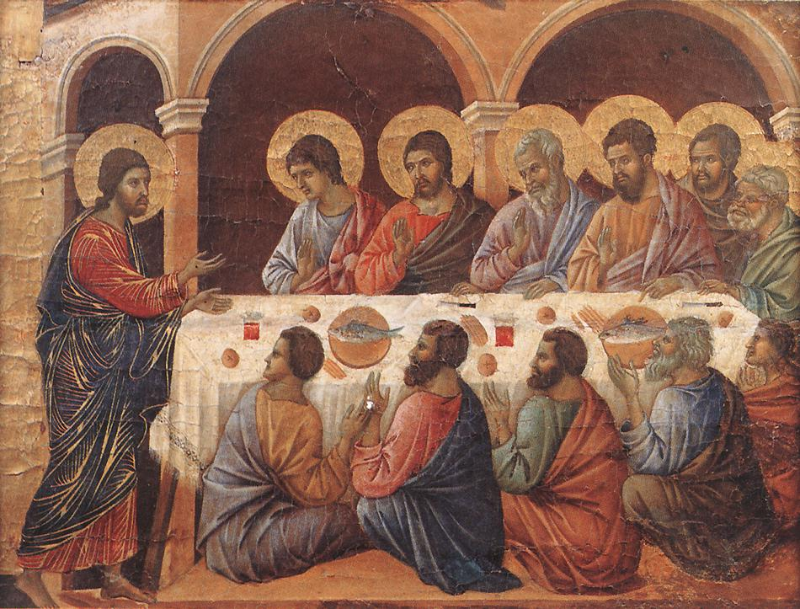

First Mennonite Church of Christian
Moundridge, KS
A welcoming Community of Christians for Peace
May 19, 2019

Announcements

Summer Sunday school: will be inter-generational taught by Laura for June 2, 9, 16 and 30. On June 9 James and Lynette Allen will serve breakfast casserole at 9:00 and end serving at 9:45 followed by coffee and visiting time. The months of July and August there will be no Sunday school

We will join Eden Mennonite church at Camp Mennoscah July 13-14. Below are costs for various overnight accommodations. Keep these in mind and plan accordingly for your stay. More info about the weekend schedule will be forthcoming.
Below are the per-person rates:
Adult/Child Overnight:
Tent/RV $15.00/$7.50,
Cabin $17.50/8.75,
Bunk House $23.00/$11.50.
A room in the Retreat Center is $77 per night for 2 people. You may add others to a room for $22.00 per person. Limit 4 people per room. Adult/Child Day Rate $7:00/$4:00

Mennonite Economic Development Associates (MEDA) Kansas Network Hub and Hesston College Aviation will partner for an evening learning event and catered meal on Tuesday, June 4, at the Hesston College hangar at the Newton (Kan.) City/County Airport, 502 N. Oliver. The programming and meal are free though donations are welcome to help with expenses. Reservations are required by Friday, May 31 or until maximum capacity is reached. RSVP at meda.org/kansas-event or to sballard@harperindustries.com or 620-896-7381. The evening’s programming will include tours of the Hesston College Aviation facility and airplane fleet, meeting the instructors, information about the flight training program and the recent addition of a four-year bachelor degree, and demonstrations on the simulated advanced training device.

MCC Opportunities:
Opportunities to serve with MCC in Haiti - Tired of ‘cubicle-based’ work? Here’s a chance to use your storytelling, writing, photography, creativity, listening and learning in a different setting! MCC Haiti is looking for a communications coordinator to use their multi-media skills to share the context, challenges and solutions of local partners more broadly. For more info about the role and to see what MCC Haiti is doing currently with their communications work, visit www.haitimcc.org. Then, dust off your language learning skills and apply today!! The close date for this position is July 26, with a starting date of October 28, 2019. https://mcc.org/get-involved/serve/openings/communications-coordinator-mcc-haiti
MCC needs your help to replenish supplies in our Material Resources Center! The following items are running low: black and white spools of all-purpose thread, minimum 250 yards, for Sewing Kits (each kit has 3 spools of each color in it). Lotion, minimum 10 oz, for Returning Citizen Care Kits and sanitary napkins, thin maxi, any count, for Relief Kits. MCC only distributes complete kits, so when we are low on one item the processing of the entire kit comes to a halt. Items for kits can be dropped off or shipped to MCC Central States, 121 E. 30th, PO Box 235, North Newton, KS 67117. Questions? Check out the kits page at mcc.org/kits or contact katemast@mcc.org.

Opportunities
Today: 9:15AM First Perk
9:30AM Sunday School
10:30AM Worship Service

May 20: Moundridge Middle School 8th Grade Promotion, 7:00 pm
May 23: Worship Team Meeting, 11:00AM
June 2: Intergenerational Sunday school in Fellowship Hall for all ages, 9:30AM
June 2: Communion service, 10:30AM
June 6-9: Pastor Laura out of office
June 9: Church Breakfast 9:00AM,
Guest Speaker Michael Unruh from Camp Mennoscah, 10:30AM
July 2-6: MCUSA Convention, Pastor Laura out of office
June 19: Deacons Meeting, 7:00PM, Board Meeting, 8:00PM
July 13-14: Camp Mennoscah with Eden Church
July 16-19: Community Vacation Bible School

Sunday May 26: Organist-Hazel Voth, Greeters-James & Lynette Allen, Worship Leader-Edna Stucky

We seek and practice Shalom

“May I be a guard for those who need protection
A guide for those on the path
A boat, a raft, a bridge for those who wish to cross the flood
May I be a lamp in the darkness
A resting place for the weary
A healing medicine for all who are sick
A vase of plenty, a tree of miracles
And for the boundless multitudes of living beings
May I bring sustenance and awakening
Enduring like the earth and sky
Until all beings are freed from sorrow
And all are awakened.”
Bodhisattva Prayer for Humanity

