First Mennonite Church of Christian
Pastor Laura Goerzen, Organist–Haze; Voth, Greeters–Tom & Diana Graber, Worship Leader–Caryl Tieszen
May 5, 2019

Gathering and Praising
Prelude
Welcome
Announcements
Gathering Words:
Leader: Grace unto you and peace from God,
Who was and who is and who is to come,
People: and from Jesus Christ, the faithful witness
The first born of the dead, ruler above all rulers of the earth.
Leader: In love Jesus Christ suffered death to free us from our sins,
People: making all who confess Christ a nation of priests
Set aside for God’s service.
All: To Jesus Christ be glory and power forever and ever!
Opening Prayer
*Gathering Hymn “Oh, for a thousand tongues to sing” #110
*Passing the Peace
New Testament Reading – Mark 8:27-35, John 21:1-14
Pete Speaks – A Monologue
Hymn of Praise – “Lord, I am fondly, earnestly” #514

Receiving God’s Word
Sermon “Simon Peter: Big Mouth, Big Failures, Big Heart”
Laura Goerzen
Hymn of Response “Beneath the cross of Jesus” #250

Sharing with One Another
Sharing Joys and Concerns
Prayer of the Church
Offertory
Offertory Prayer
Going in God’s Name
*Sending Song “Strong, righteous man of Galilee” #540
*Benediction
Postlude

*Those who are able are invited to stand

Pastor Laura Goerzen
Pastor Laura’s email: laura.n.goerzen@gmail.com
Pastor Laura’s Cell Phone: 620-386-0518
Pastor’s office Hours: Tues.—Fri. 9:30AM-1:30PM
Study Phone 620-345-8766
Church Secretary: Lurline Wiens
Lurline’s phone number: 620-345-6657
Lurline’s email: fmcc.secretary1@gmail.com
Office hours: Tues. 1:00-4:00PM, Thurs-Fri. 8:30AM-12:00pm
Church Phone: 620-345-2546
Church Website: www.fmccmoundridge.org

.
Jesus’ Disciples: Peter

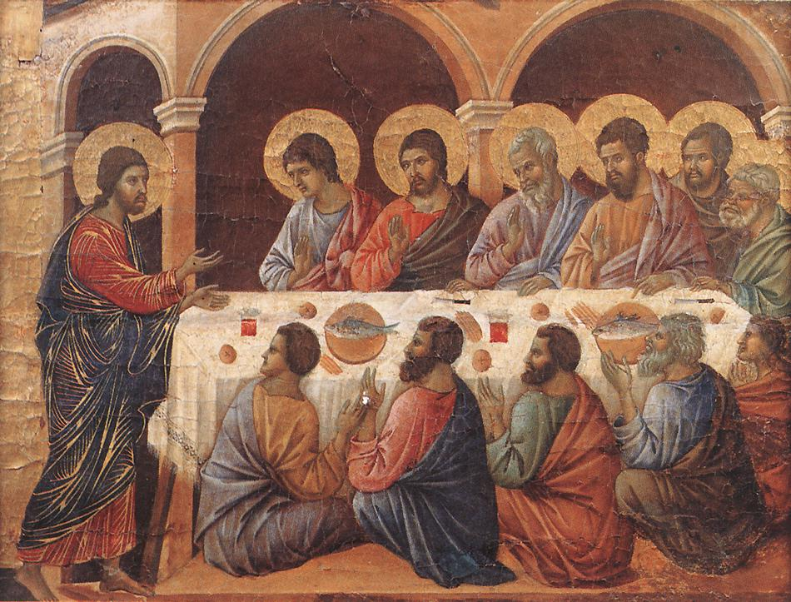

First Mennonite Church of Christian
Moundridge, KS
A welcoming Community of Christians for Peace
May 5, 2019

Opportunities
Today: 9:15AM First Perk
9:30AM Graduate Reception
10:30AM Worship Service

May 8: Deacons meeting at 7:00PM, Board meeting at 8:00PM

May 13: Friendship Circle Salad luncheon, 12:00 pm

May 18: Moundridge High School Graduation, 2:00 pm

May 20: Moundridge Middle School 8th Grade Promotion, 7:00 pm

May 23: Worship Team Meeting, 9:30AM

June 9: Church Breakfast 9:30AM,
Guest Speaker Michael Unruh from Camp Mennoscah, 10:30AM

Sunday May 12: Organist-Roberta Gingerich, Greeters-Tom & Diana Graber, Worship Leader-Pat Goering

We seek and practice Shalom

Let us outdo each other in being helpful and kind to each other
and in doing good.
- Hebrews 10: 24 TLB

Announcements

Friendship Circle: Salad luncheon is Monday, May 13, at 12:00 pm. Bring a salad to share, bread, dessert and drink will be furnished. Come enjoy fellowship around the table and play some games after lunch.

You are invited: to attend the Kansas Mennonite Relief Sale Annual Meeting scheduled for Thursday, May 23, 6:00 pm, at First Mennonite Church, McPherson. The cost for the meal is $15/person and you will pay at the door. Please RSVP to your MCC Sale Liaison, Ferd Wiens, or Barb Reeves at bj.reeves@live.com or 620-543-6863. RSVP deadline is May 19.

2019 Graduates From Our FMCC Family

Bethel College
Elizabeth Ratzlaff – daughter of James & Karen Ratzlaff
Caleb Allen – son of James & Lynette Allen
Alec Loganbill – grandson of Varden Loganbill

Moundridge High School
Arturo Vivanco – son of Arturo & Maria Vivanco
Kevin Vivanco – song of Arturo & Maria Vivanco
Cayman Wiens – granddaughter of Ferd & Lurline Wiens

Moundridge Middle School, 8th Grade
MaKaleb Unruh – son of Nicole Unruh

