First Mennonite Church of Christian
Pastor Laura Goerzen, Organists-Hazel Voth & Roberta Gingerich, Greeters-Rick & Pat Krehbiel, Worship Leader–Gordon Goering
June 16, 2019

Gathering and Praising
Prelude
Welcome
Announcements
Opening Prayer
*Gathering Hymn – “Holy Spirit, come with power” #26
*Passing the Peace
Scripture Reading – Luke 8:1-3, 10:38-42
Hymn of Praise – “Immortal, invisible, God only wise #70

Receiving God’s Word
Sermon -“Did you know?” Laura Goerzen
Hymn of Response – “How can we be silent” STJ #61

Sharing with One Another
Sharing Joys and Concerns
Prayer of the Church
Offertory
Offertory Prayer

Going in God’s Name
*Sung Benediction – “Be thou my vision” #545
*Benediction
Postlude

*Those who are able are invited to stand

Pastor Laura Goerzen
Pastor Laura’s email: laura.n.goerzen@gmail.com
Pastor Laura’s Cell Phone: 620-386-0518
Pastor’s office Hours: Tues.—Fri. 9:30AM-1:30PM
Study Phone 620-345-8766
Church Secretary: Lurline Wiens
Lurline’s phone number: 620-345-6657
Lurline’s email: fmcc.secretary1@gmail.com
Office hours: Tues. 1:00-4:00PM, Thurs-Fri. 8:30AM-12:00pm
Church Phone: 620-345-2546
Church Website: www.fmccmoundridge.org

Jesus’ Disciples: Mary, Martha, and More
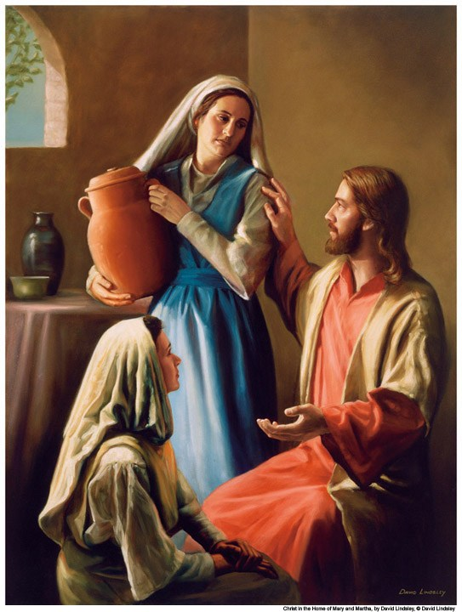

First Mennonite Church of Christian
Moundridge, KS
A welcoming Community of Christians for Peace
June 16, 2019

Opportunities
Today: 9:15AM First Perk
9:30AM Sunday School
10:30AM Worship Service

June 19: Deacons Meeting, 7:00PM, Board Meeting, 8:00PM

June 21-22: MCC comforter mini blitz

June 30: put together infant care kits during Sunday School

July 2-6: MCUSA Convention, Pastor Laura out of office

July 7: Guest Speaker Lee Suderman

July 13-14: Camp Mennoscah with Eden Church

July 16-19: Community Vacation Bible School

August 13-16: Music Camp at FMCC, 9:30AM-11:00AM

August 18: Peace Sunday, Rick Krehbiel & Gordon Goering report during Sunday School, Kathy Neufeld Dunn will preach, potluck following

Sunday June 23: Organist-Roberta Gingerich, Greeters-James Ratzlaff family, Worship Leader-Pat Goering

We seek and practice Shalom

A candle loses nothing of its light by lighting another candle.

Announcements
God loves children! Collecting MCC infant kits: As part of our focus on God’s love for children during our June 30 Sunday school hour, we will assemble infant care kits for MCC. Bring your donated items to church any time before 9:30 am on June 30. New items only, sizes 3-12 months.
3 gowns/sleepers (flannel or similar warm, soft material)
3 undershirts/onesies (short or long sleeves)
1 receiving blanket (light weight fleece or flannel, minimum 30 in x 30 in, larger sizes preferred)
4 large, heavy-duty safety pins
1 large bar mild soap (leave in wrapper)
1 pair of socks
1 cap

Did you know FMCC has a website? You can access recent bulletins, a guide to our cemetery, and other information about our church at www.fmccmoundridge.org.

Associated Ministries of Moundridge: minutes from the May 16, 2019 meeting are on the south bulletin board for anyone interested in reading them.

Moundridge Community Blood Drive: is scheduled for Friday, June 28 from 12:00 noon to 6:00 p.m. at Pine Village Wellness Center. To make an appointment visit www.redcrossblood.org and enter the code: Moundridge, OR call 1-800-733-2767. Walk-ins are welcome as well.

Lunch in the park: if you know of a child who needs help with meals this summer, please let them know about Lunch in the Park. Every Tuesday from 11:30-12:00 this summer there will be a free lunch available at Black Kettle Park for kids in the community. More information is on the board.

Cemetery Cleanup: If you want the flowers you placed on graves for Memorial Day, please pick them up by July 4, otherwise, they will be thrown away.
Peace Sunday: We will be observing Peace Sunday at FMCC August 18. At 9:30AM, Rick Krehbiel and Gordon Goering will share observations and reflections from their participation in MCC's Texas Borderlands Learning Tour. At 10:30AM, we will worship with guest speaker, Kathy Neufeld Dunn, who also attended the Learning Tour. A potluck will follow.

Make plans to join in the fun at the MCC Comforter Mini Blitz at MCC in North Newton! If you can tie a knot, then you can certainly tie a comforter, all ages are welcome!! Friday, June 21 from 9-5; Saturday, June 22 from 8-4; drop in or stay for the day! You are welcome to bring a snack to share and if you stay through lunch you’ll need a sack lunch, too. Contact katemast@mc.org for more information.
Mennonite Central Committee Central States is hiring for a Young Adult Program Coordinator. This position is available starting on August 5 within the 16-state Central States region. The Young Adult Program Coordinator coordinates and recruits for MCC Central States’ young adult programs, including the International Volunteer Exchange Program (IVEP), Summer Service Worker (SSW) program, the Serving and Learning Together (SALT) program, and Seed. This position connects with Central States' young adult alumni, especially using social media, and creates opportunities for young adults from the Central States region to serve and develop leadership skills. The full job description is available at serve.mcc.org. . Please contact Heidi Huber at heidihuber@mcc.org for more information.

On Saturday evening, June 29, at 7:00 p.m. Walking Roots Band will be giving a concert at Whitestone Mennonite Church in Hesston. A free will offering will be collected to help pay travel and tour expenses. The Walking Roots Band, from Harrisonburg, VA, are doing a short tour before some of their members lead music for the joint worship sessions at MC USA Assembly (MennoCon ’19) in Kansas City. Youth who attended the Orlando Convention in 2017 will remember Seth Chrissman who led music at Orlando and is part of the Walking Roots Band.

Bethel College Notes:
Sun., June 23 – Jim Kauffman, grandson of Kauffman Museum founder Charles Kauffman, will sign copies of his new book, Kauffman: Three Merchants of Integrity, 3-4 p.m. at Kauffman Museum. This 2018 family biography tells the story of Jim Kauffman’s father, Lloyd, his grandfather, Charles and his great-grandfather, Jacob. Books will be for sale at the June 23 event. For more information, contact Andi Schmidt Andres, asa@bethelks.edu or 316-283-1612.
Fri., June 28 – Kauffman Museum will host an opening reception for a new temporary exhibit, “Walk A Mile,” an expressive arts project that features art created by EmberHope, Youthville's residential children, 4-6 p.m. “Walk A Mile” will be on display at the museum – free of charge in the outer lobby – June 29-July 22 (more of the exhibit will be on display at Carriage Factory Gallery, Newton, June 20-July 11, and the entire collection will be at Mark Arts, Wichita, Aug. 17-Sept. 14). For more information contact Michael Reinschmidt, mreinschmidt@bethelks.edu or 316-283-1612.
MCC urgently seeks host home in the Newton area: Silav Yea, a 24 year old from Cambodia will be serving through MCC’s International Volunteer Exchange Program (IVEP) beginning in August. She will be working at both Prairie Harvest and the Newton Et Cetera Shop for her one year service term. Curious to learn more? Check out the flier in your mailbox or contact Sara Dick at generalmanger@netwonectertashop.com.

