First Mennonite Church of Christian
Pastor Laura Goerzen, Organist – Bev Hasan,
Worship Leader – John Goerzen
June 20, 2021

Gathering and Praising
Prelude

Introit John Goerzen
Welcome

Announcements

Call to Worship

One: You who open doors and dismantle barriers,
Many: open our hearts to praise you,
One: that we might live the full truth of who we are,
Many: that we might live as neighbors and friends, no longer strangers and enemies;
One: open our hearts to the transforming power of your love,
Many: that we might forgive and reconcile
One: making peace and learning war no more,
Many: that we might be your people,
One: one body in one Spirit,
Many: to tell your grace to all the world.
One: We pray in the name of the One who walked among us as brother and friend.
ALL: Amen.

*Song – “We are People of God’s Peace” VT #797

Scripture Reading – Luke 10:25-37

Children’s Time
My Coins Count

Special Music John Goerzen

Receiving God’s Word

Sermon - “Pray for Peace, Act for Peace” Laura Goerzen

Hymn of Response – “Be a Sower” VT #789

Sharing with One Another

Sharing Joys and Prayer Requests

Prayer of the Church

Going in God’s Name

*Sending Song – “Take my Life and Let it Be” VT #759
*Benediction

Postlude

*Those who are able are invited to stand

Pastor Laura Goerzen
Pastor Laura’s email: laura.n.goerzen@gmail.com
Pastor Laura’s Cell Phone: 620-386-0518
Pastor’s office Hours: Mon. 10:00AM-Noon, Wed/Thurs. 10:00AM-3:00PM

Study Phone 620-345-8766
Church Secretary: Lurline Wiens
Lurline’s phone number: 620-345-6657
Lurline’s email: fmcc.secretary1@gmail.com
Office hours: Tues. 1:00-4:30PM, Thurs-Fri. 8:30AM-11:30am
Church Phone: 620-345-2546
Church Website: www.fmccmoundridge.org

Portraits of Faith:
Laura’s concluding exhortations

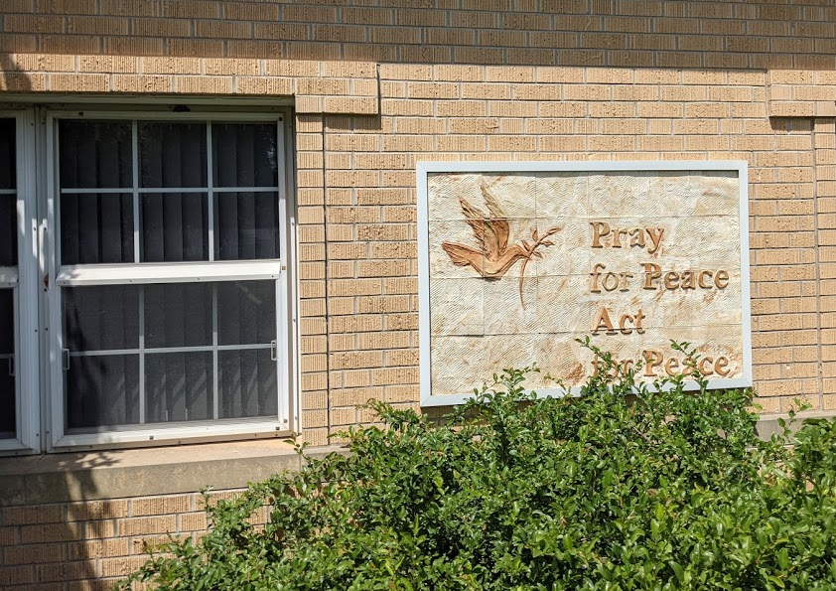

First Mennonite Church of Christian
Moundridge, KS
A welcoming Community of Christians for Peace
June 20, 2021

Volunteers needed to make this year's Relief Sale possible. Please visit our sale website and plan to help a shift or two. Also, help is needed to make Verenika on Wednesday, June 30 in Hillsboro for the Feeding the Multitude meal: https://kansas.mccsale.org/volunteer/.

New in the Library:
“Until There is Justice” - Jennifer Scanlon
“Tornado! Up from the Debris’
“Long Shot” – Jeff Boschee
“The Heart of a King” – Jill Eileen Smith

Opportunities
Today: 10:30 Worship Service

June 23: Worship Team, 10:00 am
June 23: Board Meeting, 8:00 pm
June 26: FEWZ fundraiser, Pickle Ball Tourny at Greer, 8:00 am
June 27: Church Business Meeting to discuss a statement on same-sex marriage (to make one, or not to make one) 9:00 am in Fellowship Hall. 10:30am worship with guest speaker: Eric Litwiller from the Mental Health Association of South Central Kansas
June 28-July 1: Pastor Laura traveling to Fresno, CA for memorial service for her uncle, Larry Warkentin
July 2 & 3: KS MCC Relief Sale
July 4: FMCC Singers, practice at 9:30 am
July 11: Laura’s last Sunday
July 15: Laura’s last day in the office

Sunday, June 27: Pianist – Lu Goering, Worship Leader – Gin Niehage, Special music – Bev Hasan

I don’t know what your destiny will be, but one thing I know — the only ones among you who will be really happy are those who have sought and found how to serve.
- Albert Schweitzer

Announcements
.

Church Business Meeting, Sunday, June 27, 9:00am. This is a follow up meeting to our consensus conversation surrounding same-sex marriage. We will discuss together the pros/cons of making a statement and, if the group decides to make a statement, we will have a number of possible statements (submitted by members of the congregation) ready to consider. If you would like to offer a statement for consideration please contact Pastor Laura. Those offering a statement must have attended the consensus meeting on June 6 and make some attempt to speak to the diversity of feelings present.

“My coins count”: we will collect coins through the month of June. Bring your coins and let’s support MCC.

On July 11, Laura’s last Sunday with us, we will have a catered meal to send her and John off. There is a signup sheet on the south bulletin board.
Please sign your name if will be attending the meal.

Pies for MCC Sale: There are 10 pie pans on the north table in the foyer that need to be filled for the MCC Sale. Pick up one, or pick up all! Rhubarb, peach, raisin, blueberry go really quickly, cherry and apple go a little bit slower. Bake what you love.

APPLIANCES AVAILABLE. If you are interested in the old refrigerator or old microwave from the kitchen, be sure to put your name on a slip of paper and place it in the labeled envelope. See the south bulletin board.
Rather than selecting a Saturday for church clean up, we were trying a signup method. Sign up for a project that you’d want to do and then coordinate times with the others. You can choose your day and time. See the south bulletin board for a signup sheet.
The Moundridge Community Blood Drive is scheduled for June 25, 2021 at 12:00 noon until 6:00 PM at West Zion Mennonite Church. Please enter through the west doors only. For an appointment call 1-800-733-2767 or visit www.redcrossblood.org and use “Moundridge” for the sponsor code. Thank you for your support. If you have any questions, call Carol at 620-345-6774 or email bczerger@mtelco.net.

FEWZ Pickle Ball Tournament Fundraiser, will be Saturday, June 26, at Greer Gym. Play will begin at 8:00 am. The tournament is limited to 24 participants and all skill levels are welcome. There is a $20 suggested donation. Registration will be done online only at https://forms.gle/upmkmL8yCELHFbZA6. There is brochure on the south bulletin with all the info.

Mark your calendars for Vacation Bible School, three nights: July 11-13 at West Zion! We’re looking forward to getting VBS started again after a year off, and we need volunteers to make it happen. Can you help? VBS is a great time to reach out and connect kids to the love of Christ. Contact Lory Fisher with questions or to volunteer! (620-794-6125; huffycross58@gmail.com)

Family Weekend at Camp Mennoscah on July 17-18! If you are looking for a weekend to escape, Family Weekend offers a smorgasbord of camp activities for you to choose from and plenty of time to roam the river and be with your family and friends. Register at campmennoscah.org and contact 620-297-3290 with questions!
Extra help and hands needed for summer youth camps! Camp Mennoscah has paid and volunteer positions for grounds, maintenance and custodial positions. For those of college age, there is a weekly stipend position that could be a lifeguard, grounds, or custodial position. Contact Camp Mennoscah at 620-297-3290 or olivia.bartel@campmennoscah.org for details. You will make camp an amazing experience for everyone!
A team from Bethel College will participate this week (June 22-25) in the 2021 Institute for Truth, Racial Healing & Transformation (TRHT) Campus Centers. The American Association of Colleges & Universities sponsors the training institute, conducted virtually this year, which has as its goal to dismantle belief in a racial hierarchy based on skin color, physical characteristics and/or country of origin, as a way to eliminate racism. Bethel is one of 78 institutions (the only one from Kansas) that will be participating in the training in order to explore forming TRHT centers on their own campuses. Bethel’s team is Christine Crouse-Dick, Peter Goerzen, Robert Milliman, Sheryl Wilson and Kirsten Zerger.

