First Mennonite Church of Christian
Pastor Laura Goerzen, Organists-Roberta Gingerich, Greeters-James Ratzlaff family, Worship Leader–Pat Goering
June 23, 2019
Gathering and Praising
Prelude
Welcome
Announcements
Call to Worship:
God desires to gather us as a hen gathers her chicks, so come! Leave behind your distractions, your pride, and your misdirected love, and crawl under the sheltering wing of God’s care. Come and Worship our loving God!
Opening Prayer
*Gathering Hymn – “Come, gracious Spirit” #303
*Passing the Peace
Scripture Reading – Genesis 3:1-13

Receiving God’s Word
Sermonette 1 -“Pride” Laura Goerzen
Hymn of Response – “From the depths of sin” #136
Children’s Story – “Two Wolves”
Prayer of Confession:
Leader: Holy God, we confess that we are a people who want to be noticed by others.
People: we want our accomplishments, our contributions, our gifts, our achievements to be seen, acknowledged, and celebrated.
Leader: We forget in the longing for recognition that it’s not what we do, or the impressions we make, that’s noticed.
People: Forgive us, gentle God, when we lose sight of you from whom our value comes. Draw us closer to you, whisper in our ears, remind us of how you see us.
Leader: Beloved friends, hear these words from God as assurance: “God leads the humble in what is right, and teaches the humble God’s way” (Psalm 25:9).
Scripture Reading – Philippians 2:5-11
Sermonette 2 – “Humility”
Hymn of response – “Amazing Grace” #143, v. 1-3

Sharing with One Another
Sharing Joys and Concerns
Prayer of the Church
Offertory
Offertory Prayer
Going in God’s Name
*Sung Benediction – “You are salt for the earth” #226
*Benediction
Postlude

*Those who are able are invited to stand
Pastor Laura Goerzen
Pastor Laura’s email: laura.n.goerzen@gmail.com
Pastor Laura’s Cell Phone: 620-386-0518
Pastor’s office Hours: Tues.—Fri. 9:30AM-1:30PM
Study Phone 620-345-8766
Church Secretary: Lurline Wiens
Lurline’s phone number: 620-345-6657
Lurline’s email: fmcc.secretary1@gmail.com
Office hours: Tues. 1:00-4:00PM, Thurs-Fri. 8:30AM-12:00pm
Church Phone: 620-345-2546
Church Website: www.fmccmoundridge.org

Snakes and Ladders:
Vices and Virtues
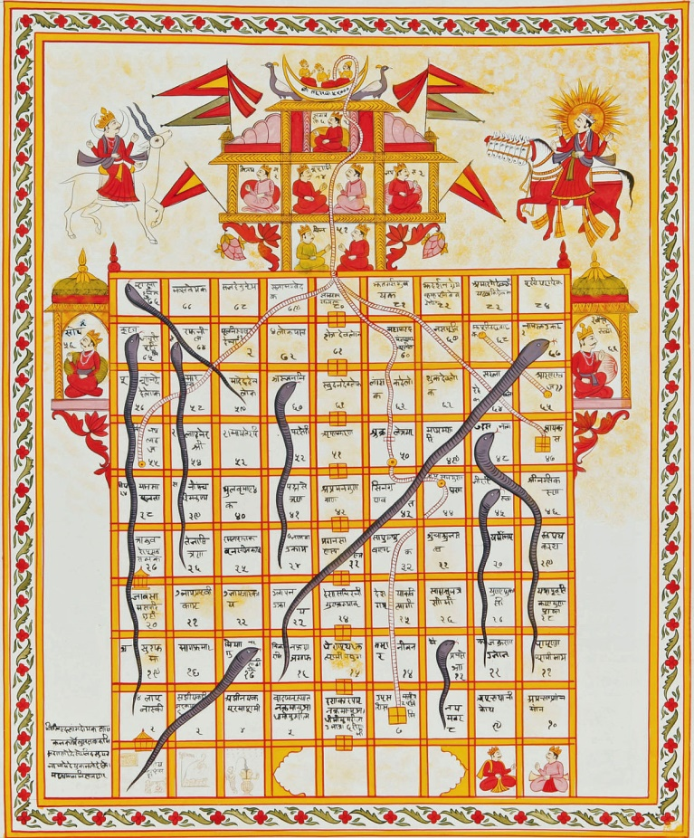
First Mennonite Church of Christian
Moundridge, KS
A welcoming Community of Christians for Peace
June 23, 2019

Opportunities
Today: 9:15AM First Perk
9:30AM Sunday School
10:30AM Worship Service

June 30: put together infant care kits during Sunday School

July 2-6: MCUSA Convention, Pastor Laura out of office

July 7: Guest Speaker Lee Suderman

July 13-14: Camp Mennoscah with Eden Church

July 16-19: Community Vacation Bible School

August 13-16: Music Camp at FMCC, 9:30AM-11:00AM

August 18: Peace Sunday, Rick Krehbiel & Gordon Goering report during Sunday School, Kathy Neufeld Dunn will preach, potluck following

Sunday June 30: Organist-Bev Hasan, Greeters-Jerroll & Carol Goebel, Worship Leader-Gin Niehage

We seek and practice Shalom

Let us not give up meeting together, as some are in the habit of doing, but let us encourage one another — and all the more as you see the day approaching.
- Hebrews 10: 25

Announcements

God loves children! Collecting MCC infant kits: As part of our focus on God’s love for children during our June 30 Sunday school hour, we will assemble infant care kits for MCC. Bring your donated items to church any time before 9:30 am on June 30. New items only, sizes 3-12 months.
3 gowns/sleepers (flannel or similar warm, soft material)
3 undershirts/onesies (short or long sleeves)
1 receiving blanket (light weight fleece or flannel, minimum 30 in x 30 in, larger sizes preferred)
4 large, heavy-duty safety pins
1 large bar mild soap (leave in wrapper)
1 pair of socks
1 cap

Did you know FMCC has a website? You can access recent bulletins, a guide to our cemetery, and other information about our church at www.fmccmoundridge.org.

Associated Ministries of Moundridge: minutes from the May 16, 2019 meeting are on the south bulletin board for anyone interested in reading them.

Cemetery Cleanup: If you want the flowers you placed on graves for Memorial Day, please pick them up by July 4, otherwise, they will be thrown away.

Moundridge Community Blood Drive: is scheduled for Friday, June 28 from 12:00 noon to 6:00 p.m. at Pine Village Wellness Center. To make an appointment visit www.redcrossblood.org and enter the code: Moundridge, OR call 1-800-733-2767. Walk-ins are welcome as well.

Camp Mennoscah: Below are the per-person rates:
Adult/Child Overnight:
Tent/RV $15.00/$7.50,
Cabin $17.50/8.75,
Bunk House $23.00/$11.50.
A room in the Retreat Center is $77 per night for 2 people. You may add others to a room for $22 per person. Limit 4 people per room. Adult/Child Day Rate - $7.00/44.00

There is a signup sheet on the south bulletin board for attending camp. Please put your name and whether or not you are interested in staying in the Retreat Center. There is also a place to mark if you are interested in attending Sunday only.

Delegates needed for Western District Annual Assembly. Come to Bethel College in North Newton July 26-27 to hear inspirational messages from MCUSA Executive Director Glen Guyton, "How a military man found peace in Jesus," Moises Romero, "How immigrants show Jesus' love," Lois Barrett and Dorothy Nickel Friesen, "How ordained women have preached good news for over 40 years," and Brian Stucky, "How our peace witness isn't always perfect." FMCC can send up to five delegates, so don't be shy! Registration is $95. Contact Pastor Laura if interested.
Signup sheet for VBS: There is a signup sheet on the south bulletin board for donations our church is asked to furnish for vacation Bible School.
Peace Sunday: We will be observing Peace Sunday at FMCC August 18. At 9:30AM, Rick Krehbiel and Gordon Goering will share observations and reflections from their participation in MCC's Texas Borderlands Learning Tour. At 10:30AM, we will worship with guest speaker, Kathy Neufeld Dunn, who also attended the Learning Tour. A potluck will follow.

On Saturday evening, June 29, at 7:00 p.m. Walking Roots Band will be giving a concert at Whitestone Mennonite Church in Hesston. A free will offering will be collected to help pay travel and tour expenses. The Walking Roots Band, from Harrisonburg, VA, are doing a short tour before some of their members lead music for the joint worship sessions at MC USA Assembly (MennoCon ’19) in Kansas City. Youth who attended the Orlando Convention in 2017 will remember Seth Chrissman who led music at Orlando and is part of the Walking Roots Band.
Mennonite Central Committee Central States is hiring for a Young Adult Program Coordinator. This position is available starting on August 5 within the 16-state Central States region. The Young Adult Program Coordinator coordinates and recruits for MCC Central States’ young adult programs, including the International Volunteer Exchange Program (IVEP), Summer Service Worker (SSW) program, the Serving and Learning Together (SALT) program, and Seed. This position connects with Central States' young adult alumni, especially using social media, and creates opportunities for young adults from the Central States region to serve and develop leadership skills. The full job description is available at serve.mcc.org. . Please contact Heidi Huber at heidihuber@mcc.org for more information.
Fri., June 28 – Kauffman Museum will host an opening reception for a new temporary exhibit, “Walk A Mile,” an expressive arts project that features art created by EmberHope, Youthville's residential children, 4-6 p.m. “Walk A Mile” will be on display at the museum – free of charge in the outer lobby – June 29-July 22 (more of the exhibit will be on display at Carriage Factory Gallery, Newton, June 20-July 11, and the entire collection will be at Mark Arts, Wichita, Aug. 17-Sept. 14). For more information contact Michael Reinschmidt, mreinschmidt@bethelks.edu or 316-283-1612.

