First Mennonite Church of Christian
Pastor Laura Goerzen, Pianist – Lu Goering, Greeters – Gin Niehage & Nicole Unruh, Worship Leader – John Goerzen
July 21, 2019
Gathering and Praising
Prelude
Welcome
Announcements
Call to Worship:
Leader: Seek the Lord while he may be found.
People: Seek the Lord in the empty places,
Leader: Seek the Lord in the wilderness of your life,
People: Seek the Lord among those who also seek him.
Leader: Seek the Lord, and he shall be found.
All: And it will be enough.
Opening Prayer

*Gathering Hymn – “This is God’s Wondrous World” insert
*Passing the Peace
Scripture Reading – Luke 12:13-21
Children’s Story – “One Grain of Rice”
Special Music – “One Pair of Hands” Music video
Receiving God’s Word
Sermonette 1 – “Greed” Pastor Laura
Hymn of Response – “Touch the Earth Lightly” insert
Prayer of confession:
Leader: Generous God, we are a people who always want more; more money, more things, more stuff, more.
People: We are a people who want bigger, we are a people who want things faster, newer, smarter.
Leader: We confess that we are a people who can never have enough—there is always something missing, there is always something better than what we have.
People: God, we confess that we try to fill the emptiness within with outside things, but they never satisfy.
Leader: Forgive us, God of abundance, remind us that what we have is enough, that newer, faster, smarter, stronger isn’t always better.
People: Help us to notice the abundance that surrounds us. Soften our hearts and lead us to a place where we can share out of that abundance.
Leader: Beloved Friends, hear these words from God as assurance: “Jesus said to his disciples, ‘Therefore I tell you, do not worry about your life, what you will eat, or about your body, what you will wear. For life is more than food, and the body more than clothing.”
ALL: Amen.

Scripture Reading – 2 Corinthians 8:1-15
Sermonette 2 – “Generosity”
Hymn of Response – “God, whose giving” #383

Sharing with One Another
Sharing Joys and Concerns
Blessing our Prayer Quilt
Special Announcement and Prayer Request
Prayer of the Church
Offertory
Offertory Prayer
Going in God’s Name
*Sung Benediction – “Move in our midst” #418
*Benediction
Postlude
*Those who are able are invited to stand

Pastor Laura Goerzen
Pastor Laura’s email: laura.n.goerzen@gmail.com
Pastor Laura’s Cell Phone: 620-386-0518
Pastor’s office Hours: Tues.—Fri. 9:30AM-1:30PM
Study Phone 620-345-8766
Church Secretary: Lurline Wiens
Lurline’s phone number: 620-345-6657
Lurline’s email: fmcc.secretary1@gmail.com
Office hours: Tues. 1:00-4:00PM, Thurs-Fri. 8:30AM-12:00pm
Church Phone: 620-345-2546
Church Website: www.fmccmoundridge.org

Prayer for Peace
Please pray for our partners and their families from the Bradost area of Iraqi Kurdistan who lost a family member to Iran’s cross-border bombing. Last week, these Iranian bombardments killed 18-year-old Zaitoon in Bradost and injured two others. Pray that CPT Iraqi Kurdistan may faithfully continue to seek avenues that will end these bombardments with their partners’ guidance. We pray for all who suffer the bereavement of losing family and loved ones to violence.

Snakes and Ladders:
Vices and Virtues
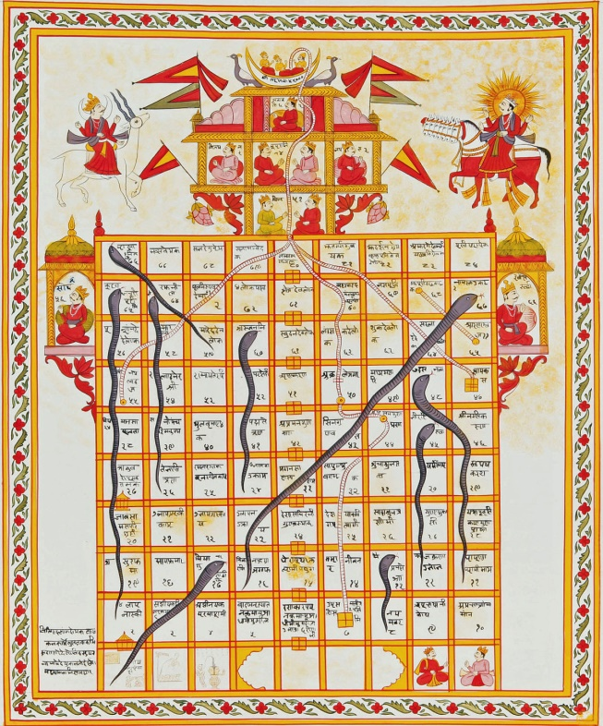
First Mennonite Church of Christian
Moundridge, KS
A welcoming Community of Christians for Peace
July 21, 2019

Opportunities
Today: 9:30AM No Sunday School
10:30AM Worship Service

July 23: conversation about LBGTQ issues with KIPCOR, 7:00 pm
July 25: Worship team meeting, 9:30 am
July 28-August 5: Laura out of the office
July 26-27: Western District General Assembly
July 28: Guest Speaker Jeff Koller
August 4: Guest Speaker Marvin Zehr
August 13-16: Music Camp at FMCC, 9:30AM-11:00AM
August 18: Peace Sunday, Rick Krehbiel & Gordon Goering report during Sunday School, Kathy Neufeld Dunn will preach, potluck following. Those who are able please bring extra food for the potluck.
August 18: Following the Peace Sunday potluck, Pastor Laura will report her findings related to conversations about the future of FMCC

Sunday July 28: Organist Bev Hasan, Greeters-Joe & Bev Zerger, Worship Leader-Pat Krehbiel, Speaker – Jeff Koller

We seek and practice Shalom
" Be especially careful when you are trying to be good so that you don’t make a performance of it. It might be good theater, but the God who made you won’t be applauding. When you do something for someone else , don’t call attention to yourself. You’ve seen them in action, I’m sure— ‘playactors’ I call them— treating prayer meeting and street corner alike as a stage, acting compassionate as long as someone is watching, playing to the crowds. They get applause, true, but that’s all they get. When you help someone out, don’t think about how it looks. Just do it— quietly and unobtrusively. That is the way your God, who conceived
you in love, working hard behind the scenes, helps you out.
Matthew 6: 1-4, The Message

Announcements

Delegates needed for Western District Annual Assembly. Come to Bethel College in North Newton July 26-27 to hear inspirational messages from MCUSA Executive Director Glen Guyton, "How a military man found peace in Jesus," Moises Romero, "How immigrants show Jesus' love," Lois Barrett and Dorothy Nickel Friesen, "How ordained women have preached good news for over 40 years," and Brian Stucky, "How our peace witness isn't always perfect." FMCC can send up to five delegates, so don't be shy! Registration is $95. Contact Pastor Laura if interested.
Let’s Talk About It! Same sex marriage and other issues related to homosexuality have been an important and pressing topic in the broader Christian church, but FMCC has not recently engaged these questions. Intern Caleb Allen is working to create an opportunity for us to learn from and listen to each other on this topic. Come to First Perk for snacks and conversation on this subject Tuesday, July 23, at 7:00PM. The Kansas Institute for Peace and Conflict Resolution (KIPCOR) will assist us by facilitating this conversation about the LGBTQ community, specifically same-sex marriage, within the greater Mennonite Church. The discussion is meant to encourage compassionate dialogue around an often avoided or misunderstood segment of our community. Expect the process, mainly small group discussions, to take about two hours. Reading materials are available in the foyer for those interested in expanding their understanding of this subject.
Peace Sunday: We will be observing Peace Sunday at FMCC August 18. At 9:30AM, Rick Krehbiel and Gordon Goering will share observations and reflections from their participation in MCC's Texas Borderlands Learning Tour. At 10:30AM, we will worship with guest speaker, Kathy Neufeld Dunn, who also attended the Learning Tour. A potluck will follow..

For our special Peace Sunday Offering, we will be collecting money for MCC Immigrant Kits. If you give for this offering, please note “MCC Immigrant Kits” on the memo of the check.

Mennonite Central Committee is now collecting Immigration detainee care kits. When people who have been placed in immigration detention centers are released, they often have nothing more than the clothes on their backs. Kits containing clothing and hygiene products can help to rebuild their dignity as they are taken to bus stations and airports to reconnect with their families in the U.S. Please visit mcc.org/immigrationkit for all the details of what goes into the kit and how the kits will be distributed. It is one small way we can share Christ’s love with our neighbors. All kit supplies should be sent to MCC Central States 121 E. 30th, PO Box 235, North Newton, KS 67117. Questions? Please contact MCC at 316.283.2720. There is info about this on the south bulletin board.

Last chance to see selections from “Walk A Mile” at Kauffman Museum this afternoon (July 21). This expressive arts project features art created by EmberHope Youthville residents. “Walk A Mile” is on display at the museum, free of charge in the outer lobby. The entire collection will be at Mark Arts, Wichita, Aug. 17-Sept. 14. Museum hours: Tues.-Fri., 9:30 a.m.-4:30 p.m., Sat.-Sun., 1:30-4:30 p.m., closed Mondays and major holidays. For more information, contact Michael Reinschmidt at Kauffman Museum, mreinschmidt@bethelks.edu or 316-283-1612.
The 2019 issue of Mennonite Life, Bethel College’s annual online journal, is now live at ml.bethelks.edu, with articles and reviews by Brad Born, Sarah Balzer, Rachel Waltner Goossen, Mark Jantzen, Donald Kraybill, Alec Loganbill, Jacob Miller, Weldon Schloneger, Keith Sprunger and Melanie Zuercher.
Are you looking for a summer sewing project? Mennonite Central Committee is running low on school kit bags! You can review the guidelines and instructions at https://mcc.org/get-involved/kits/bag. Please contact Kate Mast at katemast@mcc.org or 316-283-2720 with any questions.

New in library:
“Faithful to Laura” Kathleen Fuller
“Rachel” Marg Christine Borntrager
“Rueben” Marg Christine Borntrager
“The Haven” Suzanne Woods Fisher
“A Matter of the Heart” Tricia Peterson
“Unclobber” Colby Martin
“God and the Gay Christian” Matthew Vines
“The Bible Unwrapped” Meghan Larissa Good
“Arthur” Mikael Lindnard
“Bible Gender Sexuality” James V. Brownson
“They Called Us Enemy” George Takei

