First Mennonite Church of Christian
Pastor Peter Emery
Pianist – Lu Goering, Worship Leader – Pat Krehbiel
July 30, 2023

Gathering and Praising

Prelude

Musical Call to Worship Cameron Voth

Welcome

Morning Prayer

Announcements

Call to Worship
Leader: Welcome, friends, to this holy day.
People: We come to offer thank; we come to sing and pray.
Leader: Welcome, friends, to this time set apart,
People: A time to remember those we love, and time to remember the holy promises of God.
Leader: Welcome, friends, to this table of remembrance and joy,
People: The table where we are fed, the feast we share with many.
Leader: Welcome, friends, and let us worship God.

*Hymn –“We Praise Thee, O God” VT #91

Scripture – 1st Kings 3:5-12

Special Music Cameron Voth

Receiving God’s Word

Sermon – “You have made your servant king” Pastor Pete Emery

Sharing with One Another

Hymn for Communion – “Put Peace into Each Other’s Hands”
VT #485 (sing all 5 verses)

Sharing Joys and Prayer Requests

Celebrating Communion

Prayer of the Church

Going in God’s Name

*Sending Song – “Lead me Forth” VT #837

*Benediction

Postlude

*Those who are able are invited to stand

Pastor Pete Emery

Pastor Pete’s email: fmcc.pastorpete@gmail.com

Pastor Pete’s Cell Phone: 785-577-1447

Pastor’s office Hours: Monday-Friday 9:00 am-3:00 pm

Study Phone 620-345-8766

Church Secretary: Lurline Wiens

Lurline’s phone number: 620-345-6657
Lurline’s email: fmcc.secretary1@gmail.com
Office hours: Tues. 1:00-4:30PM, Thurs-Fri. 8:30AM-11:30am
Church Phone: 620-345-2546
Church Website: www.fmccmoundridge.org

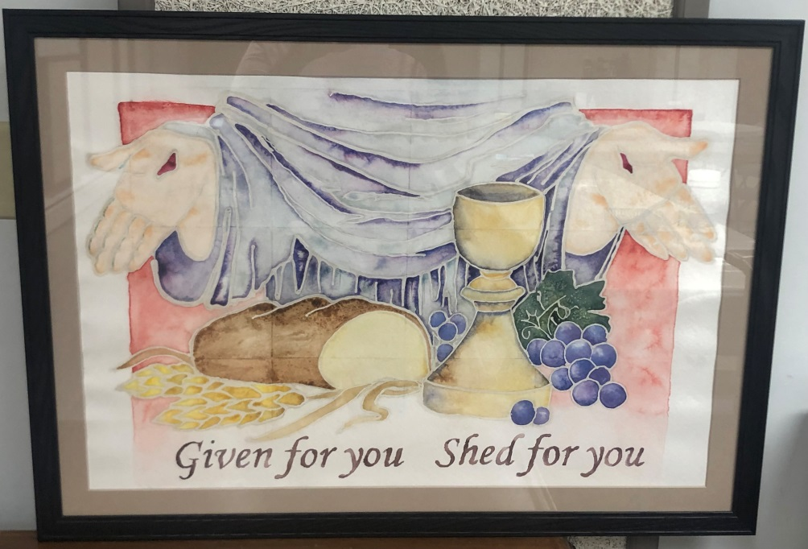

First Mennonite Church of Christian

Moundridge, KS

A Welcoming Community of Christians for Peace

July 30, 2023

PRAYER PLACES/JOYOUS JOURNEYS

Pray for Larry Goering as he is recovering from knee surgery.
Ann Storer has spent several days at Mercy Hospital. Pray for her.
Continue to Pray for the victims in the world that have been affected by weather.

God will either lighten our load or strengthen our backs. Author unknown

If you have prayer requests or items of joy, contact one of the Care Team members so we can add those requests as needed. Members are: Pat Krehbiel, Dwight Goering or Cheri Kaufman.

Opportunities

Today: 9:30: Fellowship time in First Perk
10:30: Worship Service

August 4: Library meeting, 10:00 am
August 9: Worship Team, 9:30 am
August 23: Deacons, 1:30 pm
Church Board, 7:30 pm
August 24: First Day of school for Moundridge

Sunday, August 6: Organist – Bev Hasan, Worship Leader – Pastor Pete,

Being “shut in,” which is really being “shut out” from the community — is an injustice.
- Mary Ann Osborn

Announcements

There is still some trimming that needs to be done at the cemetery. If you are able to find some time to go do a little bit, that would be greatly appreciated. Thank you

August Library Meeting, Friday, August 4, 10am

We will again collect supplies for MCC. They have some current needs listed in the paragraph below. I will put boxes in the foyer to collect supplies. If you prefer to give a check, there will be an envelope for the checks. We will collect supplies until August 4. Thank you for your participation.
MCC Material Resources Center in North Newton critically low on inventory: An MCC kit cannot be distributed until each item for the kit is assembled, but some supplies in the Material Resources Center are so low that kits cannot be processed for shipping. You can help by filling the following needs: new infant onesies and sleepers (3-12 month sizes); notebooks (70 sheets) and black or blue ballpoint pens. Locally, MCC distributes prisoner care and returning citizen care kits, for those kits we currently need: shampoo (20 oz or more), men’s deodorant (min 2.25 oz) and toothpaste (min. 5 oz). Buy online and ship it to MCC or bring items to MCC in North Newton (121 E. 30th St, North Newton, KS 67117). Questions are always welcome, please contact brociamueller@mcc.org or 316.283.2720. A full list of MCC kit contents can be found at mcc.org/kits.

Colorado Peaches are coming! The Palisade peaches on the Western Slope are supposed to be a good crop this year thanks to the moisture during the winter and spring. Please email patsydirksen@mcc.org to place your peach order from July 24-August 5. Two sizes are available: 10 lbs. for $30 and 18 lbs. for $41. Checks should be made payable to Beth-El Mennonite Church with "Peaches" in the memo line and payment (cash/check only) is due by August 5 to MCC in North Newton (121 E. 30th St.). Peaches will be available for pickup from the MCC Material Resources Center on Monday, August 21. This is a fundraiser for the Rocky Mountain Mennonite Relief Sale held in Rocky Ford, Colorado October 20-21.

The Pine Village Benefit Day Bierock Fundraiser is coming up!
We are now taking Bierock Pre-orders, which are due by Wednesday, August 2nd. You may order a half dozen for $20 or a dozen for $35. Return forms to Pine Village or order online at https://www.pinevillageks.org/benefitdaypreorders.
Join us for dinner on August 11th from 5:30-7pm. Dinner is just $7, add an extra bierock for only $3 more! We would love for you to join us in person! Pre-order pick up will be on August 11th from 3-6pm at Pine Village Wellness Center. Thank you for your support.

It’s time for the MCC School Kit Challenge! Help us meet our goal of gathering 10,000 school kits in the month of August. By donating items like notebooks and pencils, you can help kids in places like Syria, Ukraine and South Sudan who have been forced to flee their homes or struggle to afford basic school supplies. Join this effort to share a tangible message of God’s love with children around the world. Learn more about this challenge and download a free activity resource at mcc.org/school-kit-challenge.

