First Mennonite Church of Christian
Pastor Laura Goerzen, Pianist – Lu Goering, Greeters – Joe & Bev Zerger, Worship Leader – Pat Goering
August 11, 2019

Gathering and Praising
Prelude
Welcome
Announcements
Call to Worship:
Leader: Come now, let us reason together, says the Lord: Though your sins are like scarlet, do you think they shall be like snow?
People: Thought they are red like crimson, do you really think they shall become like wool?
Leader: Happy are those whose transgression is forgiven, whose sin is covered.
People: Happy are those to whom the Lord imputes no iniquity, and in whose spirit there is no deceit. Happy are those who are transformed to receive and share God’s love.

Opening Prayer
*Gathering Hymn – “For God so loved us” #167
*Passing the Peace
Scripture Reading – Matthew 5:27-30
Children’s Story Laura Goerzen
Special Music “We Believe” by Newsboys Gin Niehage
Receiving God’s Word
Sermonette 1 – “Lust” Laura Goerzen
Hymn of Response – “I am weak and I need thy strength” #553
Prayer of Confession:
Leader: Loving God, we are a people filled with desires. Some desires draw us closer to you; others pull us further away.
People: Some desires satisfy; others leave us wanting.
Leader: We live in a world of unlimited, untamed, and unbridled desire where around each corner there is a temptation to satisfy our own selfish desires.
People: We confess we have followed too much the devices and desires of our own hearts, and lost sight of what we truly long for: intimacy and communion with you.
Leader: Forgive us, loving God, when we misplace that longing; help us to see your face, feel your presence, hear your voice. Beloved Friends, hear God’s words of assurance; “You are God’s desire, and God’s desire is for you.” Amen.
Scripture Reading – 1 Corinthians 6:15-20
Sermonette 2 – “Chastity”
Hymn of Response – “Bless’d be the tie that binds” #421 v 1-3 & 6
Sharing with One Another
Sharing Joys and Concerns
Sharing the Lord’s Supper
Prayer of the Church
Offertory
Offertory Prayer
Going in God’s Name
*Sung Benediction – “Breathe on me, breath of God” #356 v 1-3
*Benediction
Postlude

*Those who are able are invited to stand

Pastor Laura Goerzen
Pastor Laura’s email: laura.n.goerzen@gmail.com
Pastor Laura’s Cell Phone: 620-386-0518
Pastor’s office Hours: Tues.—Fri. 9:30AM-1:30PM
Study Phone 620-345-8766
Church Secretary: Lurline Wiens
Lurline’s phone number: 620-345-6657
Lurline’s email: fmcc.secretary1@gmail.com
Office hours: Tues. 1:00-4:00PM, Thurs-Fri. 8:30AM-12:00pm
Church Phone: 620-345-2546
Church Website: www.fmccmoundridge.org

Prayer for Peace
We pray for the families who lost loved ones in mass shootings of the last two weeks in Canoga Park and Gilroy, California; in Brooklyn, NY; in Chicago, IL; in Chippewa Falls, Wisconsin; in El Paso, TX, Dayton, OH, and other locations. We pray for the healing of physical and mental trauma for the injured and the survivors. We pray for a healing of white supremacy in the United States—in the halls of power, in the media, in the education system—everywhere it has taken root, for racism is inextricably bound with current gun culture in the U.S.

Snakes and Ladders:
Vices and Virtues

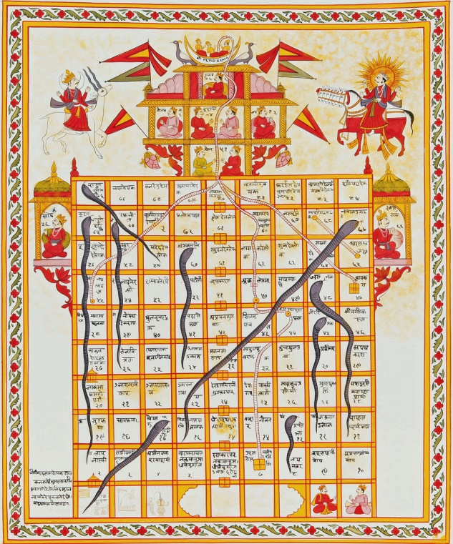

First Mennonite Church of Christian
Moundridge, KS
A welcoming Community of Christians for Peace
August 11, 2019

Announcements

Snacks needed for Music Camp! Snacks for eight children and two adults will be needed at some point between 10:00AM and 10:15AM August 13, 14, 15, and 16. Please contact Pastor Laura if you would be willing to help prepare and serve a snack for one or more of these days.

Church Neighborhood Picnic: Is set for today, August 11. There is a sign up sheet on the south bulletin board. Please check it out and sign up for where you can help.

Peace Sunday: We will be observing Peace Sunday at FMCC August 18. At 9:30AM, Rick Krehbiel and Gordon Goering will share observations and reflections from their participation in MCC's Texas Borderlands Learning Tour. At 10:30AM, we will worship with guest speaker, Kathy Neufeld Dunn, who also attended the Learning Tour. A potluck will follow. Those who are able please bring extra food for the potluck.

For our special Peace Sunday Offering, we will be collecting money for MCC Immigrant Kits. If you give for this offering, please note “MCC Immigrant Kits” on the memo of the check.
We are collecting supplies for school kits! We will be putting kits together on Sunday August 25 at 9:30. The school sales are going now. Here is the list for supplies:
Contents (NEW items only)
- 4 spiral or perforated-pages notebooks (8.5 in x 10.5 in and 70 sheets)
- 8 new unsharpened pencils
- 1 ruler (flat, good quality; must indicate 30 cm; inch markings optional)
- 12 colored pencils (in packaging)
- 1 large eraser
- 2 new black or blue ballpoint pens
- 1 small all metal pencil sharpener, one or two holes. All metal sharpeners can be found online at Amazon.com or Bazic.com.or in the art supply section of retail stores like Staples. Plastic case pencil sharpeners are not accepted because these are poor quality and do not last as long. If you cannot find all metal sharpeners please pack the kits without them and we will add the sharpeners. 96 pencil sharpeners have already been purchased so there isn’t a big need for them.

Where is the Prayer Quilt? The Prayer Quilt is with Bev Hasan.

Are you looking for a summer sewing project? Mennonite Central Committee is running low on school kit bags! You can review the guidelines and instructions at https://mcc.org/get-involved/kits/bag. Please contact Kate Mast at katemast@mcc.org or 316-283-2720 with any questions.
You're invited to Just Desserts, Offender/Victim Ministries' summer fundraiser. Join us Saturday, August 24 from 7-9pm at Carriage Factory Art Gallery park (128 E 6th St, Newton) for an evening of sweet treats, live music, and good company. Come meet current volunteers and learn more about OVM's work in our community. Tickets available online or through our office. Call (316) 283-2038 or visit our Facebook page for more information. https://www.eventbrite.com/e/just-desserts-tickets-64393594976

RSVP now for MCC Lunch & Learn on August 15: Come to MCC for lunch and to hear from participants who recently went on the MCC South Texas Borderlands Learning Tour. They will share about their experiences and reflections on the trip. Lunch is served at noon and the presentation will start shortly after. A suggested donation of $10 is welcome to help cover the cost of lunch. Please plan to join us for lunch, all are welcome. RSVP by Monday, Aug. 12 to patsydirksen@mcc.org or 316.283.2720, MCC Central States, 121 E. 30th St., North Newton, KS 67117.

Opportunities
Today: 9:30AM No Sunday School
10:30AM Worship Service

August 11: Neighborhood Church Picnic

August 13-16: Music Camp at FMCC, 9:30AM-11:00AM

August 18: Peace Sunday, Rick Krehbiel & Gordon Goering report during Sunday School, Kathy Neufeld Dunn will preach, potluck following. Those who are able please bring extra food for the potluck.

August 18: Following the Peace Sunday potluck, Pastor Laura will report her findings related to conversations about the future of FMCC

August 28: Worship Team, 9:30 am
August 28: Deacons Meeting, 7:00PM, Board Meeting, 8:00PM

September 1: Sandwich meal served 11:30AM, followed by congregational conversation about our path forward

Sunday August 18: Pianist – Luke Ratzlaff, Greeters – Pam Frey & Julie Whittle, Worship Leader – Edna Stucky, Special Music – Steve & Cheri Kaufman

If you only listen to what others say, you’ll never hear yourself think.
- John David Anderson, Posted

