First Mennonite Church of Christian
Pastor Laura Goerzen, Organist – Bev Hasan, Greeters – Lu Goering & Renee Steinert , Worship Leader – Lurline Wiens
August 25, 2019

Gathering and Praising
Prelude
Welcome
Announcements
Call to Worship:
Leader: Holy God, we come this day to this place of worship with empty hands and empty hearts.
People: What we have is never enough for our tired souls.
All: Fill us with your Spirit, and it will be sufficient.

Opening Prayer
*Gathering Hymn – “Praise to the Lord, the Almighty” #37
*Passing the Peace
Scripture Reading – Ecclesiastes 6:7-9
Special Music - “How great thou art” (insert)
Receiving God’s Word
Sermonette 1 – “Gluttony” Laura Goerzen
Hymn of Response – “Don’t be afraid” STJ #105
Prayer of Confession
Leader: Gracious God, each day we’re met with images of sumptuous, tempting, decadent, filling things.
People: We confess that often we receive the benefits of second helpings, extra portions, and supersizes. And while we often leave our tables overly full, there are others around the world with not enough.
Leader: We live surrounded by excess, and the more we fill ourselves, the emptier our spirits become.
People: Forgive us. Do not turn us away. Instead lead us to hunger and thirst for your righteousness. May you fill us with your good things. We pray this, trusting that it will be enough.
Leader: Beloved, hear these words from God as assurance: “Our God is able to provide you with every blessing in abundance, so that by always having enough of everything, you may share abundantly in every good work.”
Scripture Reading – Isaiah 58:6-12
Sermonette 2 – “Temperance”
Hymn of Response – “I hunger and I thirst #474 v. 1-4

Sharing with One Another
Sharing Joys and Concerns
Prayer of the Church
Offertory
Offertory Prayer

Going in God’s Name
*Sung Benediction – “The Lord lift you up” STJ #73
*Benediction
Postlude

*Those who are able are invited to stand

Pastor Laura Goerzen
Pastor Laura’s email: laura.n.goerzen@gmail.com
Pastor Laura’s Cell Phone: 620-386-0518
Pastor’s office Hours: Tues.—Fri. 9:30AM-1:30PM
Study Phone 620-345-8766
Church Secretary: Lurline Wiens
Lurline’s phone number: 620-345-6657
Lurline’s email: fmcc.secretary1@gmail.com
Office hours: Tues. 1:00-4:00PM, Thurs-Fri. 8:30AM-12:00pm
Church Phone: 620-345-2546
Church Website: www.fmccmoundridge.org
Prayer for Peace
Please pray for a conversion of hearts among all those who prey upon the migrants seeking asylum along the U.S./Mexico border. At the Agua Prieta MX/Douglas AZ crossing, migrants—primarily from Mexico but also from countries in Central and South America and all the way from Russia—come to their final destination before crossing into the U.S. where they hope they will be safe. Having dodged exploitation by mobs, they now face a system that has become increasingly exclusionary and punitive. The changes in the U.S. immigration system have created a booming industry of private detention centers, massive militarization in Douglas and other border cities, which has led to even greater exploitation of migrants. In gratitude we pray for the many communities of faith and individuals of good will who offer a temporary reprieve from danger, exploitation and exclusion with an outpouring of love and hospitality.

Snakes and Ladders:
Vices and Virtues
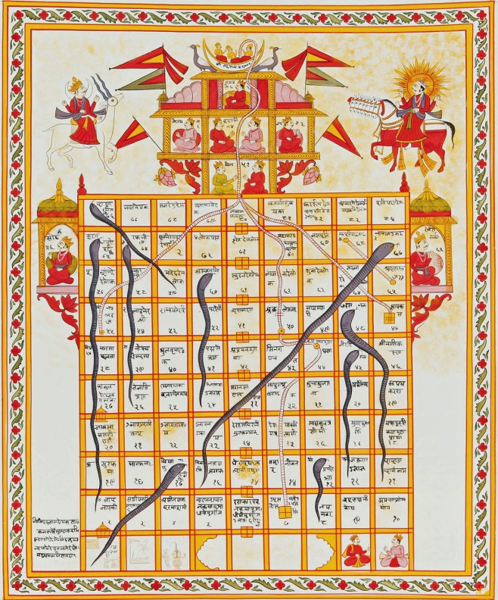
First Mennonite Church of Christian
Moundridge, KS
A welcoming Community of Christians for Peace
August 25, 2019

Opportunities

Today: 9:30AM Put together school kits
10:30AM Worship Service

August 28: Worship Team, 9:30 am
August 28: Deacons Meeting, 7:00PM, Board Meeting, 8:00PM

September 1: Sandwich meal served 11:30AM, followed by congregational conversation about our path forward

September 9: Friendship Circle salad supper & movie, 6:00 pm

October 6: World Communion Sunday

October 27: Worship Service at Pine Village

November 17: joint Mission Sunday at Eden at 9:30 am

Sunday, September 1: Organist–Roberta Gingerich, Greeters–Lu Goering & Rene Steinert, Worship Leader–Gin Niehage, Special Music– James & Lynette Allen

You shall not give false testimony against your neighbor.
- Exodus 20: 16

Announcements

Where is the Prayer Quilt? The Prayer Quilt is with Bev Hasan.

The Moundridge Community Blood Drive is scheduled for 8/30/19 at 12:00 noon until 6:00 p.m. at the Pine Village Wellness Center. For an appointment call 1-800-733-2767 or visit www.redcrossblood.org and use "Moundridge" for the sponsor code.

Out of the Office: Lurline will be out of the office from September 5- September 27. Rita Stucky will be doing the bulletins in her absence. Please try to have all announcements to the secretary email by Wednesday evening. Rita will be working on the bulletin during evening hours.

Sunday School: We will resume normal Sunday school on Sunday September 1. The 8th grade and high school Sunday school will be at our church this fall.

During Sunday school the offering is always taken. Our Sunday school offering goes for MCC relief kits. Information on where it goes and what they collect is in the foyer along with a basket for any additional money. In order to bring more awareness to the offering a thermometer is up in the foyer with an amount for a goal. Every time the offering is taken, the red on the thermometer will go up until we have reached our goal! The goal amount is for the fall quarter only. So, go to Sunday school, put money into the offering and watch the thermometer go up! Lets reach our goal!
Associated Ministries of Moundridge (AMM) has been notified that past VBS volunteer Luke Loganbill was arrested on multiple charges of lewd or indecent liberties with a child, child sexual abuse, and sexual battery. Though the allegations for which Luke was arrested did not occur in the community of Moundridge, because of Luke’s previous involvement with VBS (approximately 2012-2016) and our commitment to caring for victims and survivors of abuse, the AMM board seeks to inform the community of these charges. For more information and to see the full statement, please see the AMM website under the “VBS” heading: https://www.ammoundridge.org/our-ministries.
The annual MCC Flatlander Bike Ride: will be held on Saturday, September 21, originating at the Mennonite Central Committee (MCC) offices, 121 East 30th Street, North Newton, KS. This year’s ride will raise funds for an MCC water development project in Nigeria. Rides of approximately 35, 45, and 65 miles, as well as shorter family rides, are planned. An informational brochure is available on the south bulletin board. The brochure is also available on the MCC website: mcc.org/get-involved/events/mcc-flatlander-bicycle-ride. Or, you can register on-line at that website. Both bikers and contributors are needed! If you are not a biker but wish to contribute to this MCC project, make your check payable to MCC; write “Flatlander Bike Ride” on the memo line; and send it to: MCC, PO Box 235, North Newton, KS 67117.
Hosting a foreign exchange student: students from many countries have applied to spend a year going to high school here in the United States. Host families are needed for these students. It is a good way to learn about the culture of other countries and share our culture with other people. If you are interested in hosting a student or just want more information to make an informed decision, see Pastor Laura.

Mennonite Mission Network Workers Mark & Mary Hurst in Newton to share about their work in Australia: You are invited to join MC USA staff in the Newton offices (718 N Main St, Newton KS) to hear from Mennonite Mission Network International Service Workers, Mark & Mary Hurst, on Wednesday Sept 4th from 2-3 pm. Mark and Mary will share about their work with the Anabaptist Association of Australia and New Zealand, whom they have served with since 1990. Here is a recent article written by Mark & Mary about their work: https://www.mennonitemission.net/blog/New-Zealand%E2%80%99s-prime-minister,-trees-teach-compassionate-justice
Sun., Sept. 8 – KIPCOR Film Series, Lost Angels: Skid Row is My Home, 3 p.m., Krehbiel Auditorium in Luyken Fine Arts Center at Bethel College. Talk-back follows with James Wilson, director of New Hope Shelter, Newton, and a member of the Wichita Police Department’s Homeless Outreach Team.
The Kansas Institute for Peace and Conflict Resolution (KIPCOR) at Bethel College will be organizing a series of free public events, Sept. 8-22, on campus and in the Newton community, in connection with the 2019 Campaign Nonviolence Week of Action. Activities include film screenings, “swords into plowshares” demonstrations by Colorado Springs-based RawTools, and a lecture by Palwasha Kakar. See kipcor.orgor call 316-284-5217 for more information.

New Storage Building Dedication, September 4 at 10 a.m. – It’s not everyday that MCC gets a new building! Please plan to join us as we give thanks for the generous gifts that made the building possible and to bless the ongoing work that takes place at MCC by dedicated volunteers. A warehouse can seem boring at first glance, but it is actually an essential part of making MCC's work happen around the world. Donuts and coffee will be served the dedication service. Questions? Please call 316.283.2720.
Comforter Mini Blitz, September 27 & 28 at MCC in North Newton! If you can tie a knot, you can tie a comforter! Come and join in the fun at this relaxed, come-and-go event. Bring your friends and family! Before you know it, you'll have helped to spread warmth and love around the world to people in situations far out of their control. Hours for the event are Friday, Sept. 27 9 a.m. to 5 p.m. and Saturday, Sept. 28 8 a.m. to 4 p.m. Find out more at mcc.org/comforter-blitz. Questions, contact katemast@mcc.org, 316.283.2720.

