First Mennonite Church of Christian
Organist – Bev Hasan, Worship Leader – Lurline Wiens
August 8, 2021

Gathering and Praising

Prelude

Welcome

Morning Prayer

Announcements

Call to Worship

Leader: God invites us to gather in this space.
People: Come, let us worship.
Leader: God loves us to care for one another.
People: Come, let us worship.
Leader: God guides us on a journey to shalom.
People: Come let us worship.
Leader: At God’s invitation, with love in our hearts, let us journey together.
People: Come, let us worship.

*Song – “Come , Christians, Join to Sing” VT #28
“Holy, Holy, Holy” VT #76 vs 1-3

Scripture Reading – 2 Peter 1:3-8

Offering (put your offering in the plate at the back of the church)

Story Time – Hymn Stories Lurline Wiens

Special Music Lu Goering

Receiving God’s Word

Sermon Dwight Goering

Hymn of Response–“Lord, I want to be a Christian” VT #558

Sharing with One Another

Sharing Joys and Prayer Requests

Prayer of the Church

Going in God’s Name

*Song – “He Leadeth Me” Blue Hymnal #599 vs 1-3

*Benediction

Postlude

*Those who are able are invited to stand

Church Secretary: Lurline Wiens
Lurline’s phone number: 620-345-6657
Lurline’s email: fmcc.secretary1@gmail.com
Office hours: Tues. 1:00-4:30PM, Thurs-Fri. 8:30AM-11:30am
Church Phone: 620-345-2546
Church Website: www.fmccmoundridge.org

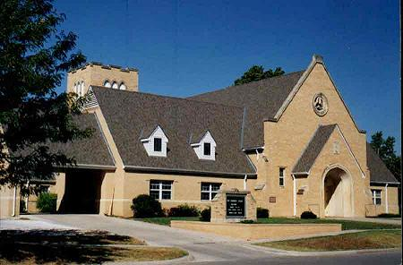

First Mennonite Church of Christian
Moundridge, KS
A welcoming Community of Christians for Peace
August 8, 2021

Opportunities
Today: 10:30 Worship Service

August 9: Library meeting. 7:00 pm
August 15: FMCC Singers practice at 9:30 am, sing during Worship Service
August 18: Worship Team, 9:30 am
August 25: Church Board, 8:00 pm

Sunday, August 15: Pianist – Delonna Barnett, Worship Leader – Randy Stucky, Special music – FMCC Singers, Speaker –

"He who passively accepts evil is as much involved in it as he who helps to perpetrate it. He who accepts evil without protesting against it is really cooperating with it.” -Martin Luther King, Jr.

Announcements

August Library Meeting, Monday, August 9, 7pm.

The September/October issue of the Upper Room is by the mail boxes.

Looking for volunteers!! STEP MC is looking for volunteers to make a meal for 15-20 people on Monday nights for their weekly meeting. Find
a friend and make the meal together OR get a Sunday School class together and help STEP-MC with their mission. It’s easy to sign up using the SignUpGenius at https://www.signupgenius.com/go/10c0d4da4a928a3fdc70-stepmc. Please call or text Connie Kaufman at 620-386-0816 OR conniejkaufman@gmail.com if you need more information.

Western District Conference is no longer sending out through email their “WDC Sprouts”, but invite you to visit their website at https://mennowdc.org/ to read the latest news, stories and announcements!

