First Mennonite Church of Christian
Pastor Laura Goerzen, Organist – Roberta Gingerich, Greeters – Lu Goering & Renee Steinert , Worship Leader – Gin Niehage
September 1, 2019

Gathering and Praising
Prelude
Welcome
Announcements
Call to Worship:
Leader: The God who created our universe
People: Who acts through history to save our world,
Leader: who reveals God’s love through Jesus and through ongoing intervention in our lives
People: calls us to the holy task of partnership in building God’s Kingdom.
Leader: Come, let us draw near in worship.
All: Let us be transformed by our calling.
Opening Prayer
*Gathering Hymn - Som’landela (We will follow) (insert) STS #40
*Passing the Peace
Scripture Reading – Matthew 27:15-26
Special Music – Go Down Moses music video
Receiving God’s Word
Sermonette 1 – “Sloth” Laura Goerzen
Hymn of Response–When we are tempted (insert) STS #81
Prayer of Confession
Leader: Some days, God, it’s easier to do nothing
People: It’s easier to wait for things to come to us: opportunities, wealth, ambition.
Leader: Between apathy and cynicism, we sit on our cushioned chairs with eyes glazing over from mind-numbing programming, waiting, letting time tick on.
People: In a world where we’re overwhelmed with injustice, sitting still in despair and not adding to the world’s problems sometimes seems the right thing to do.
Leader: But that is not what you have called us to be.
People: We confess that sometimes it’s easier to not care, to not participate, to not engage, and to avoid the world.
Leader: But your love demands participation, your love demands engagement.
People: Forgive us when we take the easy way out, when we choose to love ourselves over loving our neighbors.
Leader: When our hearts and minds yearn for escape, call us back to you and your love. Beloved friends, hear these words from God as assurance: You’ve already been told what is good, to do justice, love kindness, and walk humbly with your God. Amen.
Scripture Reading – Matthew 25:31-40
Sermonette 2 – “Joy”
Hymn of Response–I will come to you in the silence (insert) STS#49

Sharing with One Another
Sharing Joys and Concerns
Prayer of the Church
Offertory
Offertory Prayer
Going in God’s Name
*Sung Benediction-Lead me, Lord #538
*Benediction
Postlude

*Those who are able are invited to stand

Pastor Laura Goerzen
Pastor Laura’s email: laura.n.goerzen@gmail.com
Pastor Laura’s Cell Phone: 620-386-0518
Pastor’s office Hours: Tues.—Fri. 9:30AM-1:30PM
Study Phone 620-345-8766
Church Secretary: Lurline Wiens
Lurline’s phone number: 620-345-6657
Lurline’s email: fmcc.secretary1@gmail.com
Office hours: Tues. 1:00-4:00PM, Thurs-Fri. 8:30AM-12:00pm
Church Phone: 620-345-2546
Church Website: www.fmccmoundridge.org
Prayer for Peace
Please pray for the Palestinian people who have for generations lived in the Old City of Al-Khalil. Pray for their safety and wellbeing, especially when Israeli settlers come to assert their presence and take away their homes. Pray for the settlers that they may understand at least in part the wrongness of what they are doing. Pray for God’s mercy and justice to be realized among all who live and work in Al-Khalil..

Snakes and Ladders:
Vices and Virtues
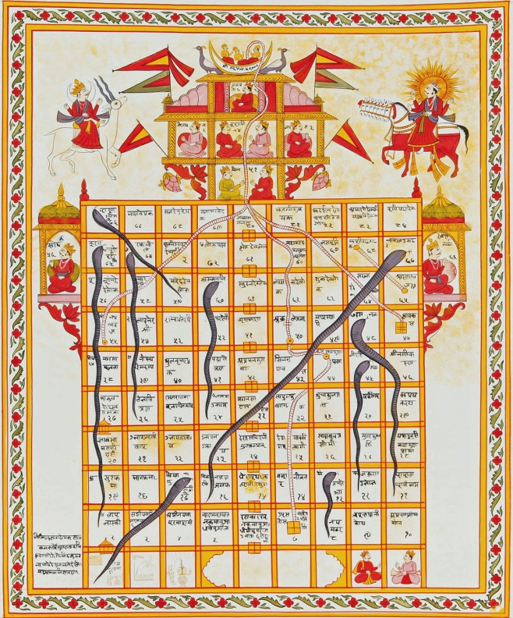
First Mennonite Church of Christian
Moundridge, KS
A welcoming Community of Christians for Peace
September 1, 2019

Opportunities

Today: 9:30AM Sunday School
10:30AM Worship Service
11:30 AM Sandwich dinner
12:30 PM Congregation conversation about the future

September 9: Friendship Circle, snacks & movie, 6:30 pm

September 17: Senior Center Fish Fry, 5-7 pm

September 29: Neighborhood ice cream social, 5:30 pm

October 6: World Communion Sunday

October 27: Worship Service at Pine Village

November 17: joint Mission Sunday at Eden at 9:30 am

Sunday, September 8: Pianist – Lu Goering, Greeters–Marlan & Marvella Ratzlaff, Worship Leader–Caryl Tieszen, Special Music– Nichole Unurh

Keep on loving each other as brothers. Do not forget to entertain strangers, for by so doing some people have entertained angels without knowing it.
- Hebrews 13: 1

Announcements

Where is the Prayer Quilt? The Prayer Quilt is with Bev Hasan.

Out of the Office: Lurline will be out of the office from September 5- September 27. Rita Stucky will be doing the bulletins in her absence. Please try to have all announcements to the secretary email by Wednesday evening. Rita will be working on the bulletin during evening hours.

During Sunday school the offering is always taken. Our Sunday school offering goes for MCC relief kits. Information on where it goes and what they collect is in the foyer along with a basket for any additional money. In order to bring more awareness to the offering a thermometer is up in the foyer with an amount for a goal. Every time the offering is taken, the red on the thermometer will go up until we have reached our goal! The goal amount is for the fall quarter only. So, go to Sunday school, put money into the offering and watch the thermometer go up! Lets reach our goal!

Friendship Circle: will meet at Gin Niehage’s, September 9 at 6:30 pm for snacks and a movie. Bring a favorite snack and come, enjoy the evening with us.

Moundridge Senior Center Annual Benefit Fish Fry: will be Tuesday, September 17, 5pm-7pm at the Senior Center. The menu is fried fish, scalloped potatoes, cole slaw, rolls, homemade pie/ice cream. The proceeds for the fish fry will go towards the purchase of window covering for the entrance doors and funds to complete ongoing renovation projects. Free will donations appreciated. Everyone welcome. Come support your local Senior Center.
Associated Ministries of Moundridge (AMM) has been notified that past VBS volunteer Luke Loganbill was arrested on multiple charges of lewd or indecent liberties with a child, child sexual abuse, and sexual battery. Though the allegations for which Luke was arrested did not occur in the community of Moundridge, because of Luke’s previous involvement with VBS (approximately 2012-2016) and our commitment to caring for victims and survivors of abuse, the AMM board seeks to inform the community of these charges. For more information and to see the full statement, please see the AMM website under the “VBS” heading: https://www.ammoundridge.org/our-ministries.
The annual MCC Flatlander Bike Ride: will be held on Saturday, September 21, originating at the Mennonite Central Committee (MCC) offices, 121 East 30th Street, North Newton, KS. This year’s ride will raise funds for an MCC water development project in Nigeria. Rides of approximately 35, 45, and 65 miles, as well as shorter family rides, are planned. An informational brochure is available on the south bulletin board. The brochure is also available on the MCC website: mcc.org/get-involved/events/mcc-flatlander-bicycle-ride. Or, you can register on-line at that website. Both bikers and contributors are needed! If you are not a biker but wish to contribute to this MCC project, make your check payable to MCC; write “Flatlander Bike Ride” on the memo line; and send it to: MCC, PO Box 235, North Newton, KS 67117.

Mennonite Mission Network Workers Mark & Mary Hurst in Newton to share about their work in Australia: You are invited to join MC USA staff in the Newton offices (718 N Main St, Newton KS) to hear from Mennonite Mission Network International Service Workers, Mark & Mary Hurst, on Wednesday Sept 4th from 2-3 pm. Mark and Mary will share about their work with the Anabaptist Association of Australia and New Zealand, whom they have served with since 1990. Here is a recent article written by Mark & Mary about their work: https://www.mennonitemission.net/blog/New-Zealand%E2%80%99s-prime-minister,-trees-teach-compassionate-justice
Sun., Sept. 8 – KIPCOR Film Series, Lost Angels: Skid Row is My Home, 3 p.m., Krehbiel Auditorium in Luyken Fine Arts Center at Bethel College. Talk-back follows with James Wilson, director of New Hope Shelter, Newton, and a member of the Wichita Police Department’s Homeless Outreach Team.
The Kansas Institute for Peace and Conflict Resolution (KIPCOR) at Bethel College will be organizing a series of free public events, Sept. 8-22, on campus and in the Newton community, in connection with the 2019 Campaign Nonviolence Week of Action. Activities include film screenings, “swords into plowshares” demonstrations by Colorado Springs-based RawTools, and a lecture by Palwasha Kakar. See kipcor.orgor call 316-284-5217 for more information.

New Storage Building Dedication, September 4 at 10 a.m. – It’s not everyday that MCC gets a new building! Please plan to join us as we give thanks for the generous gifts that made the building possible and to bless the ongoing work that takes place at MCC by dedicated volunteers. A warehouse can seem boring at first glance, but it is actually an essential part of making MCC's work happen around the world. Donuts and coffee will be served the dedication service. Questions? Please call 316.283.2720.
Comforter Mini Blitz, September 27 & 28 at MCC in North Newton! If you can tie a knot, you can tie a comforter! Come and join in the fun at this relaxed, come-and-go event. Bring your friends and family! Before you know it, you'll have helped to spread warmth and love around the world to people in situations far out of their control. Hours for the event are Friday, Sept. 27 9 a.m. to 5 p.m. and Saturday, Sept. 28 8 a.m. to 4 p.m. Find out more at mcc.org/comforter-blitz. Questions, contact katemast@mcc.org, 316.283.2720.

New In the Library
“Eating Tomorrow” Timothy Wise
“Our God is Undocumented” Ched Myers

