First Mennonite Church of Christian
Pastor Laura Goerzen, Organist – Bev Hasan, Greeters – Wilbur & Hazel Voth , Worship Leader – Pat Krehbiel
September 29, 2019

Gathering and Praising
Prelude

Introit FMCC Singers

Welcome

Announcements

Call to Worship [silence]

Opening Prayer

*Gathering Hymn – “Unto they temple, Lord, we come” #4

*Passing the Peace

Scripture Reading – 1 Kings 5:3-5, 6:2, 37-38, 7:1-2

Stories of Holy Space Randy Stucky

Special Music - FMCC Singers

Second Scripture Reading – Jeremiah 7:1-11

Receiving God’s Word

Sermon Laura Goerzen

Hymn of Response – “Where charity and love prevail” #305

Sharing with One Another

Sharing Joys and Concerns

Prayer of the Church

Offertory

Offertory Prayer

Going in God’s Name

*Sung Benediction – FMCC Singers

*Benediction

Postlude

*Those who are able are invited to stand

Pastor Laura Goerzen
Pastor Laura’s email: laura.n.goerzen@gmail.com
Pastor Laura’s Cell Phone: 620-386-0518
Pastor’s office Hours: Tues.—Fri. 9:30AM-1:30PM
Study Phone 620-345-8766
Church Secretary: Lurline Wiens
Lurline’s phone number: 620-345-6657
Lurline’s email: fmcc.secretary1@gmail.com
Office hours: Tues. 1:00-4:00PM, Thurs-Fri. 8:30AM-12:00pm
Church Phone: 620-345-2546
Church Website: www.fmccmoundridge.org

Holy Space

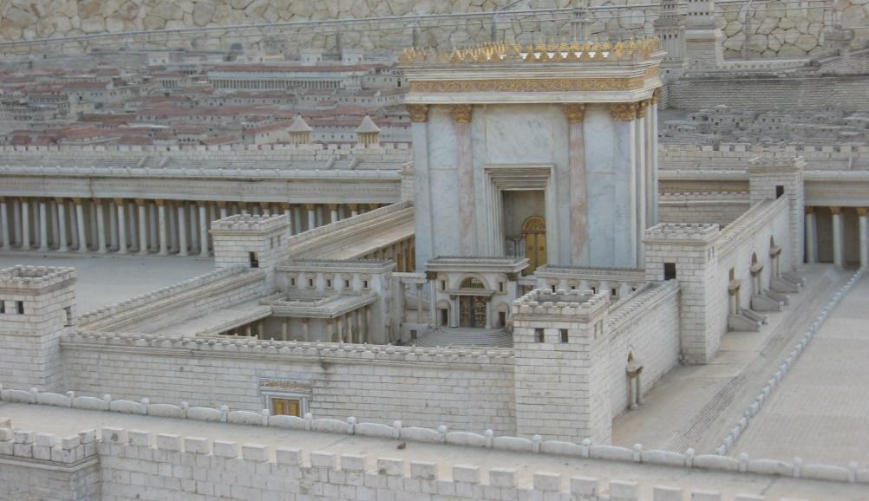

First Mennonite Church of Christian
Moundridge, KS
A welcoming Community of Christians for Peace
September 29, 2019

Opportunities

Today: 9:30AM Sunday School
10:30AM Worship Service

September 29: FMCC Singers practice 9:30am, Neighborhood ice cream social, 5:30 pm

October 6: World Communion Sunday

October 6: Snack and Dream gathering at Pat and Dwight Goering’s house, 6:00PM, come to discuss new ideas for being church

October 8: Worship team, 9:30 am

October 24: Pine Village Benefit Dinner and Auction

October 27: FMCC Singers practice 9:30am, no Sunday School Worship Service at Pine Village 10:30am

Oct. 28: Meat Canning

November 10: Harvest Thanks Offering, Potluck with Church Business Meeting following

November 17: joint Mission Sunday at Eden at 9:30 am

Sunday, October 6: Organist - Roberta Gingerich, Greeters – Ann & Andy Storer, Worship Leader – Gordon Goering, Special music – Dale & Connie Germeroth

Offer hospitality to one another without grumbling. 1 Peter 4:9

Announcements

Where is the Prayer Quilt? The Prayer Quilt is back at the church.
Medical equipment rental program: as a service of the Moundridge United Methodist Church, we have started a short term, small medical equipment rental program for Moundridge and the surrounding areas. This would involve equipment such as crutches, canes, walkers, shower seats, etc. The program is designed to be of no cost to the renter. We however would like to have the equipment returned in good condition as soon as the individual is done with it. We will clean and disinfect it for the next person. Questions concerning this program should be directed to 620-386-6453 and NOT to the church.

Hesston College invites alumni and friends to campus for Homecoming 2019, Sept. 26 to 29. The weekend offers activities for all ages, including dedications for facilities part of the Be Greater campaign - Bess Mullet Softball Field, Yost Center and the Bonnie Sowers Nursing Center, The Manickam Mosey Two-Mile Run/Walk, a disc golf tournament, a kids' festival, picnic meal and athletic events. See the full weekend schedule at hesston.edu/homecoming

Mennonite Heritage and Agricultural Museum Fall Lecture Saturday, October 5 at 9:30 am – Seagoing Cowboys and Tractors to Poland. See flyer on south bulletin board.

Sun., Oct. 6 – Bethel College Wind Ensemble and Philharmonia Orchestra joint concert, 3 p.m., Memorial Hall

Hesston College's annual Cultures Fair will be from 7 to 9 p.m., Monday, Oct. 7 in the Hesston Mennonite Church Community Center on the Hesston College campus. In fall 2019, the campus boasts students from 25 countries - many of whom will share their hearts through food, games, dance, vocal and instrumental music. A family-friendly event. Free and open to the public.
Fall Festival at Bethel College – Oct. 10-13 with most events Sat., Oct. 12; see www.bethelks.edu/fallfest/ or Fall Fest 2019 on Facebook.

Thurs., Oct. 10 – Artist reception for Kathy Schroeder, “Read the Pictures: Notes from a Visual Learner,” 6-8 p.m., Regier Gallery in Luyken Fine Arts Center at Bethel College [NOTE different day of week than in past years, and change from some printed calendars]

Bethel College Theater presents A Shayna Maidel by Barbara Lebow – Fri., Oct. 11, 7:30 p.m., Sat., Oct. 12, 3:30 p.m., Sun., Oct. 13, 2 p.m., Krehbiel Auditorium in Luyken Fine Arts Center. Tickets at Thresher Shop in Schultz Student Center, Mon.-Fri., 8 a.m.-5 p.m., or a minimum of one hour before show time in the LFAC ticket office, subject to availability.
Kauffman Museum’s monthly bird walk will be on the second Saturday in October (Oct. 12), to coincide with Bethel College’s Fall Festival.

November 3-8, join MCC for a South Texas Borderlands learning tour. This learning tour will be packed with opportunities for learning about immigration. From talking with MCC partners who work in legal representation, to those that do water drops, to providing shelter to those recently released. You will also connect with people who have lived the immigrant experience, visit Mennonite churches on the border, hear perspectives from south of the border, and visit a detention center. You will have a first-hand learning experience on the impact of policy and see the hope of incredible people working to extend God’s love and compassion for all. The cost for the trip is $700, plus airfare. Please contact anahinojosa@mcc.org or jordanpenner@mcc.org for more information.

All singers are invited to sing in the annual Hesston College Masterworks performance on Saturday, November 16. This year’s performance will be “Song of Wisdom”. Rehearsals begin October 7. For more information, go to Hesston.edu/masterworks or contact Russel Adrian at Russell.adrian@hesston.edu or 620-327-8143

