First Mennonite Church of Christian
Pastor Laura Goerzen, Pianist – Lu Goering, Greeters – Marlan & Marvella Ratzlaff , Worship Leader – Caryl Tieszen
September 8, 2019

Gathering and Praising
Prelude
Welcome
Announcements
Call to Worship:
Leader: Whether you’re young or old,
People: come, and let us worship our gracious God.
Leader: Whether you’re healthy or sick,
People: come, and let us worship our gracious god.
Leader: Whether you’re rich or poor,
People: come, and let us worship our gracious God.
Leader: Whether you’re tired or exhausted,
People: come, and let us worship our gracious God.
Leader: Whether you’re filled with righteous fury or the peace of Christ,
People: come, and let us worship our gracious God.
ALL: Come, let us worship our gracious God together today.
Opening Prayer
*Gathering Hymn – “Come let us all unite to sing” #12
*Passing the Peace
Scripture Reading – Mark 15:15-23
Special Music – provided by Nicole Unruh family
Receiving God’s Word
Sermonette 1 – “Wrath ” Laura Goerzen
Hymn of Response – “What wondrous love is this” #530
Prayer of Confession
Leader: Loving God, on this day of worship, we confess that sometimes it’s easier to be angry.
People: Transform the anger that burns in our hearts to a love that reflects your unbridled love for us.
Leader: When our hearts are hardened by revenge,
People: soften them with your forgiving love, so that in time we, too, may share the love you have mercifully shown us.
Leader: When our hearts wallow in the pool of resentment, longing for misfortune to befall our neighbors,
People: soften them by your grace so that we may offer and accept your generous love.
Leader: Forgive us when our actions do not reflect you and your love.
People: Lead us in your paths of grace and peace.
Leader: May your love move us toward reconciliation and restoration with our neighbors in our communities, with your creation in our world, and in your church.
People: May our actions and our words reflect your loving Spirit present in your Son, who demonstrated your kingdom of shalom to us.
Leader: Beloved friends, hear these words from our Lord Jesus Christ as assurance: “For God so loved the world, that he gave his only Son, that whoever believes in him, might no perish, but have everlasting life. Amen.
Scripture Reading –John 20:11-18
Sermonette 2 – “Love”
Hymn of Response – “Love divine, all loves excelling” #592

Sharing with One Another
Sharing Joys and Concerns
Prayer of the Church
Offertory
Offertory Prayer

Going in God’s Name
*Sung Benediction – “for God so loved us” #167
*Benediction
Postlude
*Those who are able are invited to stand

Pastor Laura Goerzen
Pastor Laura’s email: laura.n.goerzen@gmail.com
Pastor Laura’s Cell Phone: 620-386-0518
Pastor’s office Hours: Tues.—Fri. 9:30AM-1:30PM
Study Phone 620-345-8766
Church Secretary: Lurline Wiens
Lurline’s phone number: 620-345-6657
Lurline’s email: fmcc.secretary1@gmail.com
Office hours: Tues. 1:00-4:00PM, Thurs-Fri. 8:30AM-12:00pm
Church Phone: 620-345-2546
Church Website: www.fmccmoundridge.org

Snakes and Ladders:
Vices and Virtues
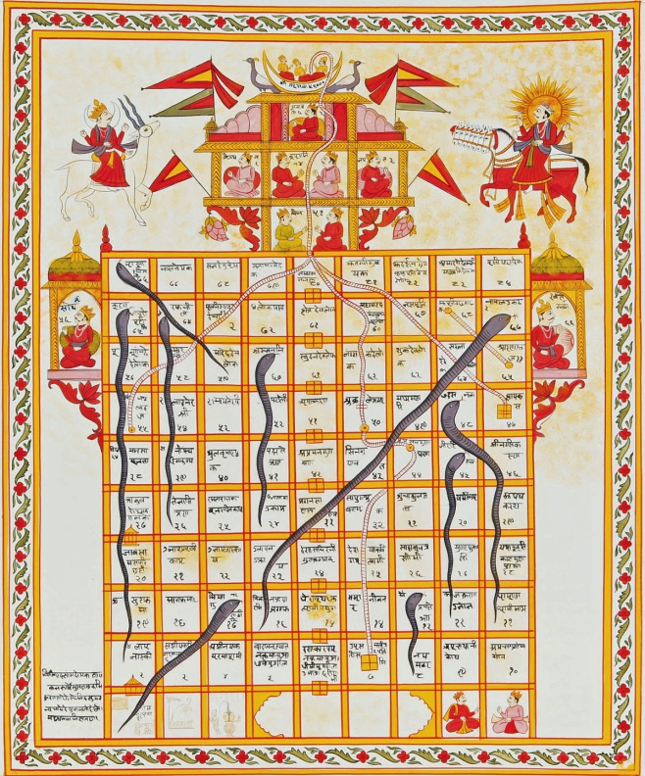
First Mennonite Church of Christian
Moundridge, KS
A welcoming Community of Christians for Peace
September 8, 2019

Announcements

Where is the Prayer Quilt? The Prayer Quilt is home at the church.

During Sunday school the offering is always taken. Our Sunday school offering goes for MCC relief kits. Information on where it goes and what they collect is in the foyer along with a basket for any additional money. In order to bring more awareness to the offering a thermometer is up in the foyer with an amount for a goal. Every time the offering is taken, the red on the thermometer will go up until we have reached our goal! The goal amount is for the fall quarter only. So, go to Sunday school, put money into the offering and watch the thermometer go up! Lets reach our goal!

The Annual Report and Fnancial statement from Associated Ministries are posted on the south bulletin board if you are interested in looking at them. These reports are available on our website at https://www.ammoundridge.org/annual-reports.

Moundridge Senior Center Annual Benefit Fish Fry: will be Tuesday, September 17, 5pm-7pm at the Senior Center. The menu is fried fish, scalloped potatoes, cole slaw, rolls, homemade pie/ice cream. The proceeds for the fish fry will go towards the purchase of window covering for the entrance doors and funds to complete ongoing renovation projects. Free will donations appreciated. Everyone welcome. Come support your local Senior Center.
The annual MCC Flatlander Bike Ride: will be held on Saturday, September 21, originating at the Mennonite Central Committee (MCC) offices, 121 East 30th Street, North Newton, KS. This year’s ride will raise funds for an MCC water development project in Nigeria. Rides of approximately 35, 45, and 65 miles, as well as shorter family rides, are planned. An informational brochure is available on the south bulletin board. The brochure is also available on the MCC website: mcc.org/get-involved/events/mcc-flatlander-bicycle-ride. Or, you can register on-line at that website. Both bikers and contributors are needed! If you are not a biker but wish to contribute to this MCC project, make your check payable to MCC; write “Flatlander Bike Ride” on the memo line; and send it to: MCC, PO Box 235, North Newton, KS 67117.

Comforter Mini Blitz, September 27 & 28 at MCC in North Newton! If you can tie a knot, you can tie a comforter! Come and join in the fun at this relaxed, come-and-go event. Bring your friends and family! Before you know it, you'll have helped to spread warmth and love around the world to people in situations far out of their control. Hours for the event are Friday, Sept. 27 9 a.m. to 5 p.m. and Saturday, Sept. 28 8 a.m. to 4 p.m. Find out more at mcc.org/comforter-blitz. Questions, contact katemast@mcc.org, 316.283.2720.
In recognition of International Day of Peace, Hesston College Bel Canto Singers and Hesston High School Singers will present a Global Voice concert, Saturday, Sept. 21, at 7 p.m., at Hesston Mennonite Church on the Hesston College campus. The concert is free and open to the public.
Hesston College invites alumni and friends to campus for Homecoming 2019, Sept. 26 to 29. The weekend offers activities for all ages, including dedications for facilities part of the Be Greater campaign - Bess Mullet Softball Field, Yost Center and the Bonnie Sowers Nursing Center, The Manickam Mosey Two-Mile Run/Walk, a disc golf tournament, a kids' festival, picnic meal and athletic events. See the full weekend schedule at hesston.edu/homecoming.

Opportunities

Today: 9:30AM Sunday School
10:30AM Worship Service

September 9: Friendship Circle snacks & movie, 6:30 pm

September 17: Senior Center Fish Fry, 5-7 pm

September 25: Deacons Meeting, 7:00pm, Board Meeting 8:00pm

September 29: FMCC Singers practice 9:30am, Neighborhood ice cream social, 5:30 pm

October 6: World Communion Sunday

October 8: Worship team, 9:30 am

October 27: FMCC Singers practice 9:30am, Worship Service at Pine Village 10:30am

November 10: Harvest Thanks Offering, Potluck with Church Business Meeting following

November 17: joint Mission Sunday at Eden at 9:30 am

Sunday, September 15: Organist – Roberta Gingerich, Greeters – Marlan & Marvella Ratzlaff, Worship Leader – Pat Goering, Special Music– Joe & Bev Zerger

Keep on loving each other as brothers. Do not forget to entertain strangers, for by so doing some people have entertained angels without knowing it.
Hebrews 13:1-2

