**We seek and practice shalom**

“Looking behind I am filled with gratitude, looking forward I am filled with vision, looking upward I am  
filled with strength, looking within I discover peace.”  
                                         - Quero Apache prayer

**Prayers for Peacemakers**

***Give thanks for Mamawe Ota Askihk (“Sharing Life Together Here on Earth”) Camp at the Sandy Saulteaux Spiritual Centre near Beausejour, MB in Treaty 1 Territory.*** The week-long camp involves ceremony, learning language and traditional ways of living, and hearing about the 7 Sacred Teachings.  Members of IPS team will be gathering with Indigenous community leaders and settler allies to “nurture one another as the earth nurtures us.”

Learn more about the Sandy Saulteaux Spiritual Centre at: [sandysaulteaux.ca](https://lists.cpt.org/sites/all/modules/civicrm/extern/url.php?u=7375&qid=1867309)

**Opportunities**

**Today**: 10:30AM Worship Service

August 29: FMCC Prayer Time, 9:30AM

August 29: Board Meeting, 8:00PM

Sept. 13: Worship Team meeting, 9:30AM

Sept. 16: Church Picnic, 5:30PM

Sept. 23: Worship at Pine Village, 10:30AM

September 2nd: Organist –, Greeters –Worship Leader –

a

Pathways to Peace

August 26, 2018

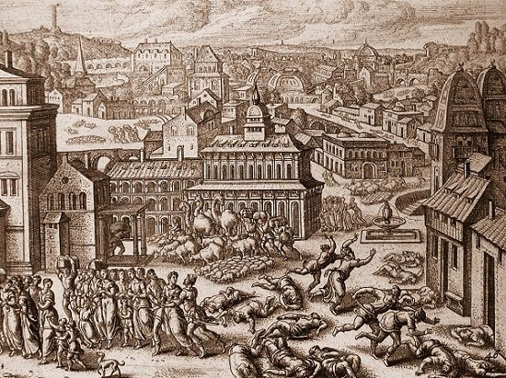

First Mennonite Church of Christian

Moundridge, KS

A Welcoming Community of Christians for Peace

**Receiving God’s Word**

Coloring Invitation Laura Goerzen

Scripture Reading Genesis 50:15-21

Sermon Laura Goerzen

We are people of God’s peace #407

**Sharing with One Another**

Sharing Joys and Concerns

Prayer of the Church

Offertory

Offertory Prayer

**Going in God’s Name**

*\* O God, our help in ages past #328, v. 1-3*

*\*Spoken Benediction*

Postlude

*\*Those who are able are invited to stand*

**Welcome to First Mennonite Church of Christian**

Pastor—Laura Goerzen, Organist –Bev Hasan , Greeters-LuVerna Goering & Renee Steinert, Worship Leader – John Goerzen

August 26, 2018

**Gathering and Praising**

Prelude

Welcome

Announcements

Opening Prayer

*\* God of grace and God of glory #366*

*\*Passing the Peace*

Scripture Reading Genesis 37:1-11

Moment in Ministry: MCC Meat Canning

Special Music Sam Shilts

Pastor: Laura Goerzen

Pastor Laura’s email: laura.n.goerzen@gmail.com

Pastor Laura’s Cell Phone: 620-386-0518

Pastor’s Office Hours: Tues.—Fri. 9:30AM-1:30PM

Study Phone: 620-345-8766

Church Secretary: Shenise Allen

Shenise’s Cell Phone: 620-334-0190

Shenise’s email: fmcc.secretary1@gmail.com

Office hours: Tuesday 3:30-4:30, Thursday 7:30-9:00

Church Phone: 620-345-2546

Church Website: [www.fmccmoundridge.org](http://www.fmccmoundridge.org)