**Opportunities**

**Today**: 9:15AM First Perk

9:45AM Sunday School

10:30AM Holy Humor Sunday

July 18: FMCC Prayer time, 9:30AM in First Perk

July 19-22: Pastor Laura out of office

July 22: Guest Speaker Tami Lundgren

July 25: FMCC Prayer time, 9:30AM in First Perk

July 27-28: WDC Annual Assembly – Those not registered are welcome to attend worship and concert events led by Brian Moyer Suderman Friday and Saturday nights at 7:00PM at Tabor Mennonite Church and Eden Mennonite Church respectively.

August 1: Board Meeting, 8:00PM

August 2: Worship Team Meeting, 9:30AM

August 5: Communion Sunday

July 22nd: Organist –Eileen Voth, Greeters –Tom & Diana Graber, Worship Leader – James Allen

**We seek and practice shalom**

     Don’t let people do that to you, put you on a pedestal like that.  You all have a single Teacher, and you are all classmates.  Don’t set people up as experts over your life, letting them tell you what to do.  Save that authority for God; let *him*tell you what to do.  No one else should carry the title of ‘Father;’ you have only one Father, and he’s in heaven.  And don’t let people maneuver you into taking charge of them.  There is only one Life-Leader for you and them —— Christ.

                                                 Matthew 23, *The Message*

**Prayers for Peacemakers**

***Pray for Christian Peacemaker Teams during its hiring process as it searches for its new Administrative Director.***

*First Mennonite Church of Christian is a fellowship that welcomes all people in our community so that they may grow in personal understanding and relationship with God. We welcome new members and guests. If you feel moved to join our fellowship or would like to know more about joining, please see the pastor.*

a

Holy Humor Sunday

July 22, 2018

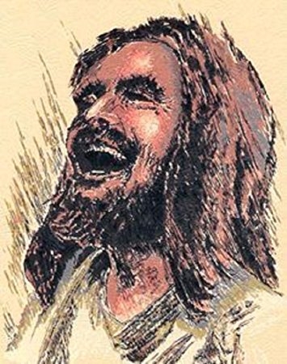

First Mennonite Church of Christian

Moundridge, KS

A Welcoming Community of Christians for Peace

**Receiving God’s Word**

Children’s Time Laura Goerzen

Special Music Luke Ratzlaff

Sarah’s Story Laura Goerzen

Quartet: John Goerzen, Steve Kaufman, Laura Goerzen, Gin Niehage “I stand amazed in the presence”

**Sharing with One Another**

Sharing Jokes, Joys, and Concerns

Prayer of the Church

Offering

Offertory

Offertory Prayer

**Going in God’s Name**

*\*You Shall Go out with Joy! #427*

*\*Spoken Benediction*

The Laughing One called us together

**so we could share in the laughter of life.**

The Laughing One sends us out,

**to carry the joy of life and love to the world.**

Go out to laugh, to live to love. And when you hear a good joke...

**remember that sharing is a great thing!**

Postlude

*\*Those who are able are invited to stand*

**Welcome to First Mennonite Church of Christian**

Pastor—Laura Goerzen, Pianist – Luke Ratzlaff, Greeters-Virginia Niehage & Nicole Unruh, Worship Leader – Lurline Wiens

July 22, 2018

**Gathering and Praising**

Prelude

Welcome

Announcements

Call to Worship

One: We believe in God, who made us in the divine image

**Many: We live, we love, we laugh, because we are like our Creator**

One: We believe in Jesus Christ, the Son of God, our Lord and Savior

**Many: He had the last laugh on the devil when God raised him from the dead**

One: We believe in the Holy Spirit, who empowers us to become new creatures

**Many: Our advocate, our guide, our motivator: the Spirit is our joy!**

One: Forgive us, Lord, when we take ourselves too seriously, when we don't claim the happiness that is rightfully ours as your children, when we forget that you will have the last laugh in this world.

***All: Restore us to the joy of our salvation, through Jesus Christ our Lord! Amen.***

Opening Prayer

*\* Take Time To Be Funny (tune of Be thou my Vision) on insert*

*\*Passing the Peace*

Scripture Reading Genesis 21:1-7

Pastor: Laura Goerzen

Pastor Laura’s email: laura.n.goerzen@gmail.com

Pastor Laura’s Cell Phone: 620-386-0518

Pastor’s Office Hours: Tues.—Fri. 9:30AM-1:30PM

Study Phone: 620-345-8766

Church Secretary: Shenise Allen

Shenise’s Cell Phone: 620-334-0190

Shenise’s email: fmcc.secretary1@gmail.com

Office hours: Tuesday 3:30-4:30, Thursday 7:30-9:00

Church Phone: 620-345-2546

Church Website: [www.fmccmoundridge.org](http://www.fmccmoundridge.org)