The earth has music for those who listen.
Opportunities
Today: 9:15AM First Perk
9:30AM Sunday School
10:30AM Worship Service
March 12: Friendship Circle, 2:00PM
March 18: Guest Speaker Kathy Neufeld Dunn
March 20-23: Pastor Laura out of office
March 25: Community Holy Week Service, 7:00PM at United Methodist Church
March 26: Community Holy Week Service, 7:00PM at United Methodist Church

March 11t^{h} -
We seek and practice shalom

- George Santayana

Prayers for Peacemakers

First Mennonite Church of Christian is a fellowship that welcomes all people in our community so that they may grow in personal understanding and relationship with God. We welcome new members and guests. If you feel moved to join our fellowship or would like to know more about joining, please see the pastor.

Between Me and You

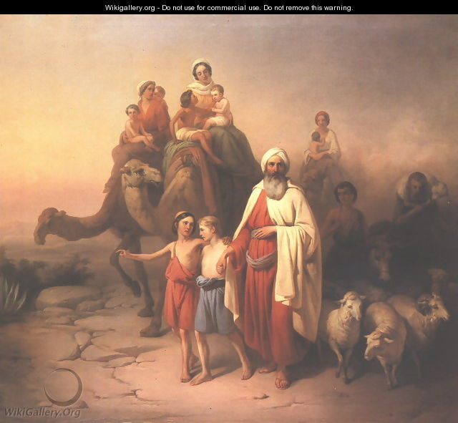

First Mennonite Church of Christian
Moundridge, KS
A Welcoming Community of Christians for Peace
March 4, 2018
Gathering and Praisin
Welcome to First Mennonite Church of Christian
Pastor – Laura Goerzen, Organist – Bev Hasan, Greeters –Rick & Pat Krehbiel, Worship Leader – James Allen
March 4, 2018

Gathering and Praising
Prelude

Welcome
Announcements
Opening Prayer

Call to Worship
Leader: Come, rule makers, rule breakers, and you who are still finding your way. Come. Whether you speak with wise words or with wisecracks, you are made in the image of God. Come into God’s house. Hear God’s Word. Prepare to meet your Maker and your match. For the foolishness of God is wiser than human wisdom, and God’s weakness is greater than human strength.
People: Some of us like certainty and structure. Some of us don’t. We come by different roads, yet we are here together. We want to know God, and to be known by God. We are here to worship the Lord.
Leader: Jesus said, “Where two or three are gathered in my name, I am there.” We are here and Christ Jesus is here. We join our hearts in worship.

*Sing Praise to God who Reigns #59

Receiving God’s Word

Scripture Reading Exodus 20:1-17

Lenten Hymn Between Me and You v.3

Children’s Time Laura Goerzen

When we walk with the Lord #544

Sermon

Prayer of Confession

*Teach me, O Lord #487

Sharing with One Another

Sharing Joys and Concerns

Praying the Psalms Psalm 19

Offering

Offertory Prayer

Going in God’s Name

*Sung Benediction Obey My Voice #163

*Spoken Benediction We are people of God.
We go in God’s love
To extend God’s love
And live God’s promise.

Postlude
*Those who are able are invited to stand

Pastor: Laura Goerzen
Pastor Laura’s email: laura.n.goerzen@gmail.com
Pastor Laura’s Cell Phone: 620-386-0518
Pastor’s Office Hours: Tues.—Fri. 9:30AM-1:30PM
Study Phone: 620-345-8766
Church Secretary: Shenise Allen
Shenise’s Cell Phone: 620-334-0190
Shenise’s email: fmcc.secretary1@gmail.com
Office hours: Monday – Thursday 4:30-7:00PM
Church Phone: 620-345-2546
Church Website: www.fmccmoundridge.org

